

Department of Computer Science
COMP4200-Introduction to Graduation Project

Manhaji
AI-Powered Personalized Learning & Performance Analytics

Prepared by:
Abdallah Mattour 1223061
Basel Bahbouh 1222263
Yaqeen Azamta 1221736

Supervise: Fasial Shehadeh
Section: 37

Section – B

Title of Project: AI-Powered Personalized Learning & Performance Analytics

Project No: 37

Supervisor: Dr. Fasial Shehadeh

Key Areas: Adaptive learning, Learning analytics, AI assessment models,
Gamification.

Section – C

Student Signature: ___________________________

Date Submitted: 21 / 11 / 2025

First Supervisor Name: Dr. Fasial Shehadeh

First Supervisor Signature: ____________________

Date Approved: 24 / 1 / 2026

Abstract

In this paper a proposal for AI based interactive learning platform targeted at early-grade students in Palestine has been presented. The system utilizes voice over narration, visual context and interactive questioning to provide literacy support for learners. One of the key characteristics is the fact that it has a speech-oriented interface that encourages student interaction with oral responses, which can be assessed through voice recognition and natural language processing. According to each student's results, the platform scales difficulty and creates a personalized learning path.
The motivation of this work is due to the general educational inconsistency (and inflexibility) that results from having pre-teens managing highly differential developmental rates and styles, especially during traditional instruction. Most of the current digital tools are not curriculum-linked and they do not include speech interaction, being this method less suitable for young children.
It also offers teachers real-time analytics on a dedicated dashboard to track progress, identify learning gaps, and intervene at the right moment. The marriage of adaptive learning, voice interactivity and local curriculum are also especially applicable in untapped educational markets.
Our study suggests that combining AI with multimodal delivery and real-time feedback can dramatically improve engagement, personalization in early learning. It is an approach that underpins scalable, inclusive education solutions.

Table of Content
Contents
Abstract 3
Table of Content 4
Table of Figures 5
List of tables 5
Acknowledgements 6
Chapter1: Introduction 7
General overview 7
Motivation and problem statement 8
Methodology 9
1.1 Aims & Objectives 10
1.2 Overview of the technical area 11
1.3 Overview of the report 11
Chapter2: Background / Literature Review 12
2.1 Details of relevant theory: 12
2.2 Review of past/reported work: 14
2.3 Tools and Technology 19
Chapter 3: System Analysis and Design 21
3.1 Product Description: 21
3.2 Functional Decomposition (Use Case Diagram) 29
3.3 System Models 33
3.4 System Architecture 47
3.5 Data Management and ERD 52
Chapter 4: Conclusion and Future works 53
Conclusion 53
Future Works 54
4.1 Review of the project 55
4.2 Next Semester Plan 56
Bibliography 57
Appendices 59
Implementation-level UML Class Diagram 59
Use Case Specifications: 60
Prototypes: 68

Table of Figures

Figure 1: ABCmouse 14
Figure 2: LittleLit.ai 15
Figure 3: Khanmigo 16
Figure 4: Manhaji 17
Figure 5:Use Cases Diagram 32
Figure 6: Conceptual class diagrams 34
Figure 7: Class Diagram 35
Figure 8: Sequence Diagram UC-1(Student Accesses Lesson Content) 37
Figure 9: Sequence Diagram UC-2 (Student Generates Gamified Quiz) 38
Figure 10: Sequence Diagram UC-5(Teacher Views Student Analytics) 39
Figure 11: Activity Diagram UC-1 (Student Accesses Lesson Content) 41
Figure 12: Activity Diagram UC-2(Student Generates Gamified Quiz) 42
Figure 13: Activity Diagram UC-5(Teacher Views Student Analytics) 43
Figure 14: State Chart Lesson Session 45
Figure 15: State Chart Gamified Quiz 46
Figure 16: Software Architecture Diagram 50
Figure 17: Deployment Diagram 51
Figure 18: ERD 52
Figure 19: Implementation-level UML Class Diagram 59
Figure 20: prototype1 68
Figure 21: prototype2 69
Figure 22: prototype3 69
Figure 23: prototype mobile 71

List of tables

Table 1: App Comparison 18

Acknowledgements

First and foremost, we would like to express our sincere gratitude to Allah for granting us the strength, patience, and ability to successfully reach this stage of our academic journey.

We would like to extend our special appreciation and thanks to Dr. Fasial Shehadeh
for his continuous guidance, valuable support, and encouragement throughout the development of this project. We are truly grateful to have him as our supervisor.

We also wish to thank all our professors, staff members, and colleagues at the Computer Science Department, Faculty of Engineering and Technology, Birzeit University, for their cooperation and support during our studies.

Finally, we would like to express our deepest thanks to our families and friends, who taught us the value of learning and provided us with unconditional support, motivation, and encouragement throughout every step of our lives.

Chapter1: Introduction

General overview

Technology incorporation has radically restructured current learning experiences, redefining modes of delivering, achieving and consolidating instruction materials. Amenities of the digital tools arsenal are now not options but an implicit aspect of modern teaching situations in which teachers teach with multiple modes and enable learners through differentiated routes.

Technology is often used as a supplement in classroom instruction and not as an alternative to traditional teaching methods. Illustrated media, interactive demonstrations and multimedia explanations enable teachers to explain concepts from various angles and provide learners with more supervised practice. When used effectively, students become better positioned for learning while educators remain the central player in the instructional process.

The increasing significance of mobile learning has gone even further to flexibilize delivery. Mobile tools provide learners with convenient access to course materials for self-study, a personalized learning experience at their own pace and the possibility to review instruction outside of traditional classrooms. It is this extended exposure that makes it especially advantageous for students who need more exposure to fundamental skills or who are unable to keep up in typical instructional environments.

Studies have consistently shown that interactive and hands-on learning environments have a positive impact on learner engagement, understanding of concepts and retention of knowledge. Yet such environments work to the extent that they are able to respond to developmental differences, particularly among young learners.

In Palestine, early childhood education is facing continuous interruptions, shortage of materials for teaching and learning and dropouts over the years at primary stages. These circumstances call for versatile and available learning platforms that can educate students outside of the conventional classroom model, while strengthening their literacy skills.

Even though educational technology has become more widespread, many of the platforms are still very text-heavy, and do not cater to early-grade learners who may lack solid reading or writing skills. This constraint is exacerbated in disrupted learning environments. In this project, we contend that curriculum-aligned, speech-enabled adaptive learning systems are not "nice-to-have" supplements for basic education; instead, they are indispensable infrastructure for effective early-grade learning under-constrained and in-flux educational conditions.

Motivation and problem statement

Today’s classrooms, especially in the early grades, though, increasingly represent a divide between how lessons are taught and how young minds learn best. The conventional, text dominated contents and the overly standardized teaching are so often out of sync with the developmental requirements of 6–9-year-old students. These students are at a foundational stage of literacy and critical thinking development — and many struggle to learn from static, one-size-fits-all content.

This dilemma is particularly apparent in settings with high levels of school disruption, and scarce resources. Palestinian students, for instance, suffer from academic disruptions and less support as well as limited use of interactive learning resources. For these students, traditional methods are just not cutting it.

Young learners today need a more responsive and engaging learning experience — one that listens to them, adapts to their needs and that speaks their language. But nearly all digital education tools are non-interactive and inflexible. They can't talk back, pause a lesson or give immediate feedback depending on how well a particular student is doing.
In addition, teachers do not have real time feedback of how each student is progressing. When lacking access to live data about student interactions with content, educators resort to infrequent assessments or conclusions of general demographics.
This project addresses that gap.
We are building an AI-powered smart learning platform. one that actually teaches more than lessons. It will streamline the delivery of sound and visual instructions, facilitate spoken communication, monitor micro-skill progression, and tailor design for individual student needs. It will also provide teachers with a robust analytics dashboard that identifies patterns of individual and class learning.

In other words: the problem we are solving is not just how to deliver education better — it is how to reimagine early stage learning experience for kids, making it interactive, adaptive and really student-centeric.

Methodology

The application incorporates various features designed to improve usability, foster desired educational outcomes and differentiate itself from competing educational applications. These features will encourage student engagement as well as provide opportunities for students to measure their own academic progress, while providing educators and parents with an effective means of tracking student progress. The features include:

- Comprehensive lessons that follow an established reading curriculum and are aligned with and include supported by appropriate school textbooks.
- Enhanced (AI-supported) simplified explanations of textbook-based questions.
- A method for students to practice reading (with voice-based pronunciation analysis) interactively.
- Student-generated quizzes where learners can select specific lessons to generate custom quizzes and earn points through gamified assessment.
- Tracking and analytics related to both student progress and teacher assessment of student performance.
- Weekly reports on student progress will be made available to parents.
- Through subscription services Teachers will have access to information concerning student progress and analytics related to student learning.
- The application will support both traditional school environments as well as independent student use.
- Using role-based authentication to control access to the application (students, teachers, and administrators).
- An intuitive user interface (designed to encourage ongoing education) will be employed.

The features of the Manhaji Application will create a structured and supportive educational environment that will improve student comprehension of subject material increase self-directed student learning and improve communication between students, parents and educators.

1.1 Aims & Objectives

Main Aim
To design and develop an AI-powered learning platform that supports early-grade students by using voice narration, visual learning aids, real-time speech-based assessments, and personalized learning paths all while providing teachers with actionable analytics to track, support, and enhance student performance.

Objectives

- Intelligent Audio-Visual Instruction:

Create a computerized lesson delivery system that provides straight forward (easy for a child to comprehend) explanations delivered with voice narration, relevant pictures and multimodal visual supports so as to aid students who do not have reading levels in reaching the messages.

- Speech-Based Student Assessment:

Utilize speech-to-text models and AI answer-analysis techniques to assess spoken answers, making it possible for young learners to take part even if they are not yet able to read/write.

- Adaptive Questioning and Micro-Skill Tracking:

Serve each student a series of questions that dynamically adapt based on their performance, engagement, and mastery of micro-concepts to ensure that each learner receives challenges appropriate to their current skill level.

- Personalized Learning Pathways:

Automatically produce personalized learning plans utilizing performance data collected by formative assessments to spot strengths and diagnose learning gaps at an early stage, with suggested lessons or practice exercises.

- Teacher Analytics and Monitoring Tools:

Provide teachers with a comprehensive dashboard displaying lesson content, student activities, real-time analytics, mastery progression, and AI-predicted risk levels to support timely intervention.

1.2 Overview of the technical area

This is a project uses AI for early grades education. It melds several technologies — voice recognition, text-to-speech, adaptive learning systems and data analytics — into a single platform that enables students to learn in a more personalized and interactive manner.

The technical relevance spans the following:
• Adaptive learning: to monitor each student’s strengths and weaknesses and adjust their lesson plan accordingly.
• Learning analytics: to provide data to teachers via a dashboard that enables educators to see what is going well and where the challenges for all pupils lie.

• Speech technologies: students can speak answers and hear lessons, rather than being able only to read them or type them.
• AI assessment models: for evaluating spoken responses and adapting questions according to the student’s level.

1.3 Overview of the report

This article describes the process of how we designed, developed, and tested an AI-based learning platform. It follows a step-by-step structure:
Chapter 1: introduces the problem to be solved and our goals.
Chapter 2: compares with related tools and explains how our idea works in contrast in more detail.
Chapter 3: is where we present in detail how we designed the system, providing flowcharts, user roles and technical architecture.
Chapter 4: is a conclusion that consolidates our result and discusses the future work.

Chapter2: Background / Literature Review

2.1 Details of relevant theory:

- Adaptive Learning Systems in Early Education:
Adaptive learning systems (ALS) personalize teaching material based on each student's performance and learning speed. This is especially important in early education, where children develop at different rates. Educational theories like mastery learning and formative assessment emphasize continuous evaluation and real-time instructional adjustment.
Many existing adaptive platforms are built for older students and depend on typed text input—something younger learners who haven’t yet mastered reading or writing may struggle with.
Manhaji takes a different approach by using speech-based interaction and real-time performance tracking. It listens to spoken input, analyzes response accuracy and error patterns, and adjusts lesson difficulty immediately—so the learning adapts while the activity is happening, not afterward.

- Learning Analytics and Micro-Skill Tracking for Early Intervention for Early Intervention:

Learning analytics help gather and analyze data to improve student outcomes. Most platforms rely on basic data points like test scores or task completion, which don’t reveal the root of learning challenges.

Recent learning analytics research emphasizes micro-skill tracking as a method for early identification of learning gaps —such as how clearly a student pronounces words, how well they understand a concept, and how consistent their answers are. It also looks at how fast they respond and how often they repeat errors to spot early signs of struggle.

This allows for early intervention and gives teachers clear, useful data. Dashboards and alerts ensure educators can respond quickly—before small gaps grow into major setbacks.

- Voice-Based Learning and Speech Analytics

Voice-based learning reduces dependence on reading and writing, which is ideal for young students. Research shows that allowing children to speak their answers and receive verbal feedback reduces mental strain and boosts engagement.

Most voice tools like digital assistants are built to recognize commands—not assess how much a child has actually learned.

Manhaji combines speech-to-text technology with AI scoring to evaluate spoken responses. It measures correctness, fluency, and consistency, gives instant feedback, and accurately tracks each student’s learning progress.

- 4.4 Gaps in Curriculum Alignment and Localization:

Many digital platforms don’t align with local educational standards, which limits how well they can be integrated into actual classrooms.

In Palestine, early education follows a structured national curriculum with clearly defined learning goals. When platforms don’t align with this, it creates gaps between what students learn online and what’s taught in school.

Manhaji is fully aligned with the Palestinian National Curriculum. Every lesson, exercise, and learning outcome is mapped directly to official standards, ensuring classroom relevance and smooth adoption in real learning environments.

2.2 Review of past/reported work:

The goal of this app is to support the education of Palestinian Students through the Palestinian National Curriculum using artificial intelligence to provide them with information that helps them better understand the material through simplified explanations and study interactive textbook questions along with the option to self-assess their understanding of each lesson after they complete it.

The feature that sets this app apart from other programs is its ability to use voice interaction, voice recognition, and voice-to-text analysis. Parents receive regular progress reports based on their child's interaction with the app and monitoring of their overall performance to provide parents with a clear picture of how well their child is doing compared to his/her peers , these are some examples of the some applications used in these areas:

- ABCmouse:

ABCmouse is a website and mobile app available on both Android and iOS platforms that was developed to assist in the education of young children (ages 2-8) through online learning activities. The site provides interactive activities that teach children reading, math, science, and art through games, books, and video lessons. Children can navigate through a structured curriculum based on their age and skill level. Parents can track their child's progress. The site’s interface is designed to be easy for young children to use, making it safe for them to access. Additionally, the lack of social interaction capability reduces the opportunities for older children to interact with children on ABCmouse.


Figure 1: ABCmouse
- LittleLit.ai:

LittleLit.ai is a web site and mobile app that uses artificial intelligence to assist young children in acquiring basic literacy skills. LittleLit.ai provides children with opportunities to read and write using the same AI-based technology as many professional authors do. LittleLit.ai encourages children to be creative and develop their language skills by allowing them to interact with AI tools to create and explore stories. The content on LittleLit.ai is designed for children of all ages and helps to promote creativity, language development, critical thinking, and other key skills. The application creates a safe, controlled environment for children to learn and provides parents and educators with guidance in guiding their children's educational journey. Lastly, LittleLit.ai has a strong emphasis on the responsible and educational use of Artificial Intelligence by young learners.

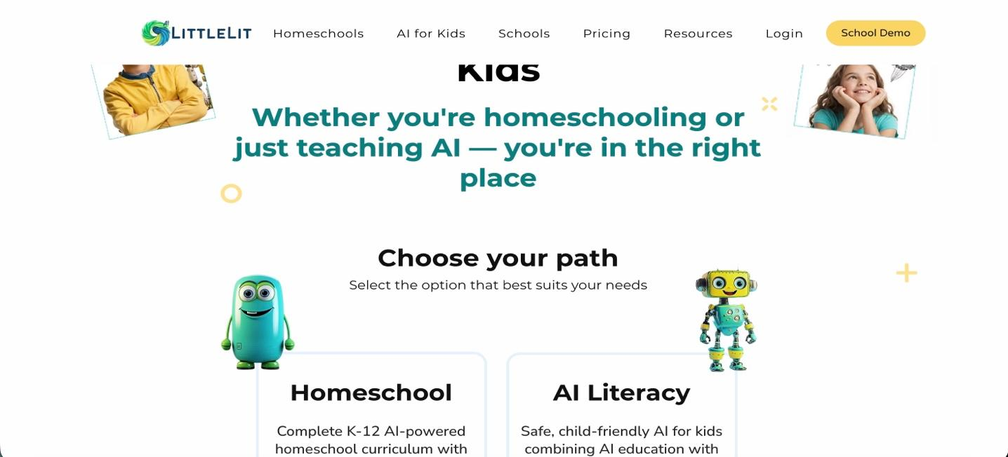
Figure 2: LittleLit.ai

- Khanmigo:

Khanmigo is an education resource and website created by Khan Academy to help educators, parents, and learners. Khanmigo offers personalized artificial intelligence (AI)-based tutoring for all learners. The Khanmigo platform provides instructions to students on how to solve problems rather than providing answers directly, and by providing guiding questions and strategies to help them develop critical thinking skills. In addition, all Khanmigo services are developed with alignment with both parent/student needs and with the best practices in teaching. Khanmigo integrates with Khan Academy to offer educational content for Mathematics, Science, Technology, and Humanities. In addition, the platform includes resources and tools for teachers to help them with lesson planning and teaching preparation.

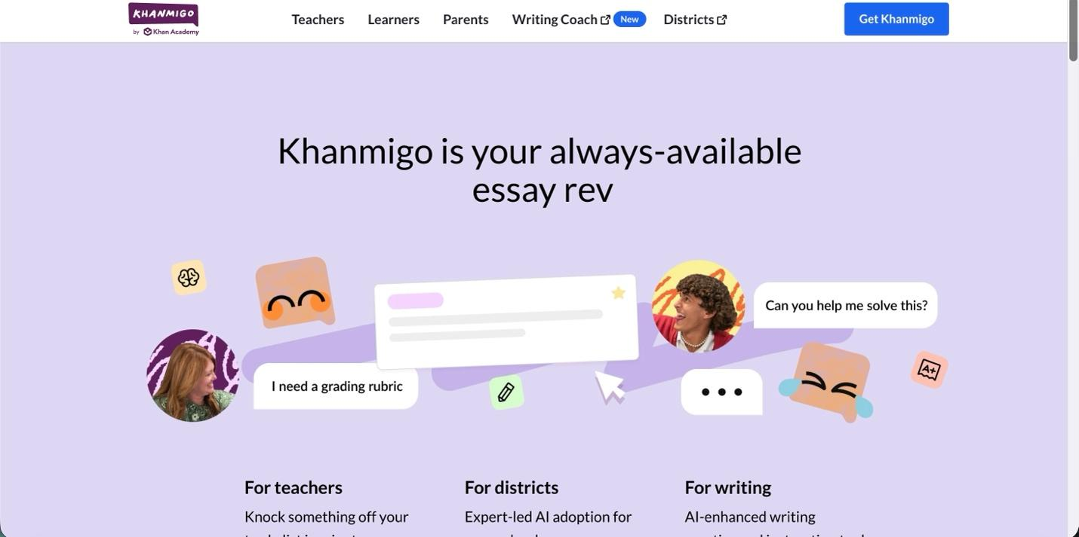
Figure 3: Khanmigo

- Manhaji:

Manhaji offers students from Grade 1 to Grade 4 an interactive approach to learn through a structure designed around the actual school curriculum. The primary goal of the app is to enhance a student’s ability to read, comprehend, and apply knowledge through structured lessons and textbook-based questions and will also provide students with a way to measure their progress over time against their lesson goals.

What sets our app apart from other similar applications available today is our emphasis on tracking and gauging student progress and tracking how teachers/parents can view those reports, and how both teachers and parents will be able to monitor their student’s learning progress. Additionally, the app has been designed to accommodate both school affiliated, and an independent learning environment, therefore it provides maximum flexibility and the greatest relevance based on the individual curriculum.

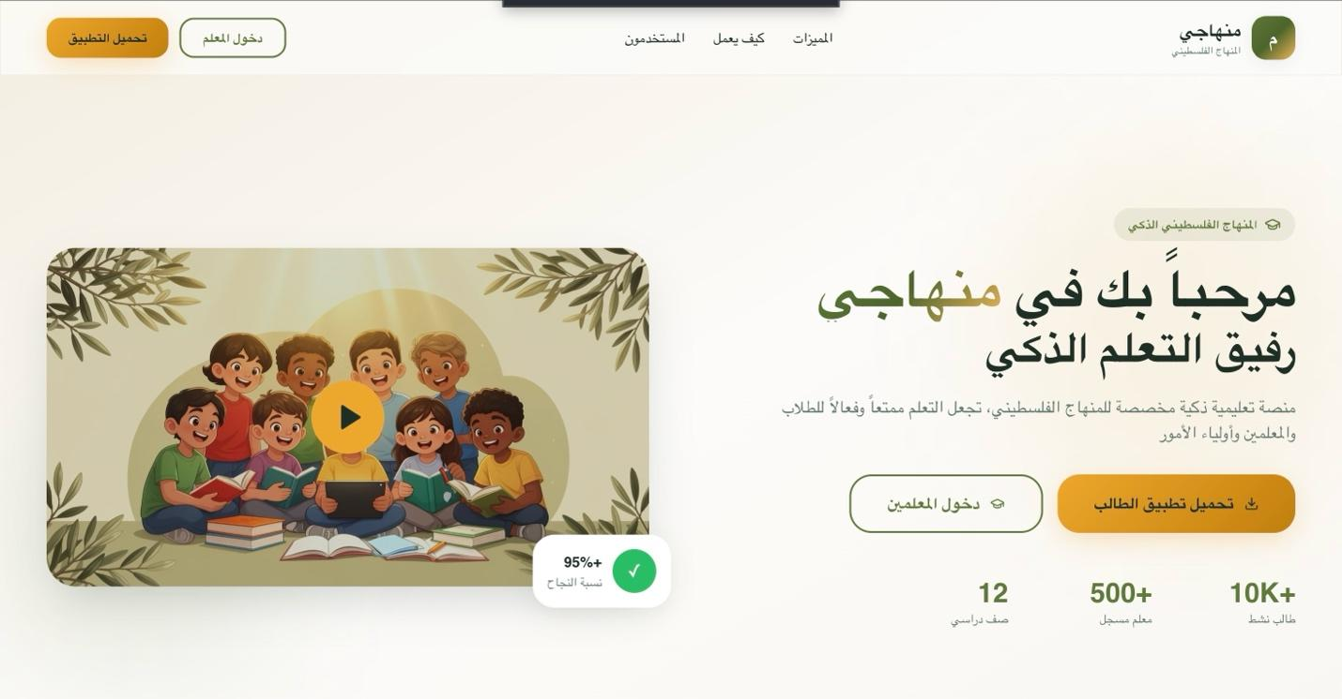
Figure 4: Manhaji

Apps Comparison
The table below shows the comparison between the mentioned websites and apps based
on some features as shown below :

Table 1: App Comparison
Khan Academy  / Khanmigo | ABCmouse | LittleLit.ai | Manhaji (Our App) | Key Feature
No | No | No | Yes | Curriculum-based learning (textbook-based)
No | No | No | Yes | Aligned with local (Palestinian) curriculum
No | No | Yes | Yes | Reading practice with voice interaction
No | No | Yes | Yes | Automatic speech / reading evaluation
Yes | Yes | No | Yes | Self-assessment quiz after each lesson
No | No | No | Yes | Quiz generated from lesson questions
Yes | Yes | Yes | Yes | Progress tracking over time
Yes | No | No | Yes | Teacher access to student progress
Limited | Yes | No | Yes | Parent access to progress reports
No | No | No | Yes | School-based usage and management
No | No | No | Yes | Designed for local educational context

2.3 Tools and Technology

Our system utilizes multiple technologies to serve both mobile and web platforms. The front-end portion of the application serves students and teachers through a functional, interactive user interface, while the back-end is responsible for managing data, users, and learning logic. The technologies chosen were based on their ability to support interactive and curriculum-driven learning while providing the foundation for a scalable and useable application.

- Flutter
Flutter is a mobile app development framework that enables developers to create applications that run on both iOS and Android devices. With Flutter, developers can create one app that works for both platforms. Flutter is also well-suited for educational apps since it provides interactive interface elements, and it allows developers to design apps with child-friendly interfaces that promote student engagement. [1]

- HTML, CSS, and JavaScript
The educational interface for teachers and administrators is developed using the combination of HTML, CSS, and JavaScript. Together, they enable the creation of visually appealing webpages with organized structures, customizable styles, and interactive features like charts, graphs and other displays. These technologies give educators the ability to easily manage their teaching resources via simple-to-use interfaces.[2]

- Spring boot
App backend is developed in Spring Boot, which is a Java-based (underlying on Google Spring Framework) software used for creating power-packed and high-performing web applications. Spring Boot is responsible for basic functions like user logins, creating/editing lessons, answering questions, subscribing to more content. Selecting Spring Boot will ensure you have a secure, partitioned and strongly-typed integration and easy access to relational databases and external APIs for your app. Some of its features like support for REST services and dependency injection helps the system to be more maintainable and scalable for long time development pools in developers community. [3]

- MySQL
The database management system (DBMS) for storing the following information is MySQL: Users; Lessons; Questions; Students' attempts (on lessons); Progress (of students). MySQL contains relational data (as opposed to non-relational), which is more easily and effectively handled using spring boot; therefore, MySQL can provide us with reports on how students are performing in their lessons.[4]

- Artificial Intelligence (AI)
Incorporating an artificial intelligence service into their systems to help students learn will include giving students simple explanations for questions in textbooks and coaching them as they answer their own homework. As a result, they will be able to enhance their own comprehension of the content while at the same time, maintain the instructor's role in that process.[5]

- Speech Recognition and Text-to-Speech
The reading and verbal responses given by students are analyzed with the help of speech recognition technology, whereas lessons and questions are read to students via text-to-speech technology. Both these technologies assist students with pronunciation practice and enhance their reading skills, particularly in the younger grades.[6]

Chapter 3: System Analysis and Design

3.1 Product Description:

Manhaji is an AIED-based learning system developed for early-grade learners
(Grade 1–4). The product offers interactive, curriculum-based lessons that are accompanied and guided by voice narrations and illustrated images with adaptive questioning to meet the varying educational needs of students.

The platform works by allowing students to listen to lessons and respond verbally, instead of only through reading or writing. Student answers are assessed by AI to judge how well they did, and the difficulty level of the lesson is modified accordingly. Using this information, it creates a personalized learning map for each student.

Manhaji also offers a teacher-facing web-based dashboard that shows real-time analytics, student progress, and skill mastery levels. It should be noted that the system is intended for classrooms as well as homeschooling, yet it is in full accordance with the Palestinian National Curriculum.

3.1.1 System Objectives:
The main objective of Manhaji is to improve early-grade learning by providing personalized and adaptive educational content.

The system aims to:

- Support students with limited reading and writing skills through voice-based interaction.
- Adjust lesson difficulty based on student performance and learning pace.
- Catch learning gaps early and provide targeted practice.
- Give teachers clear, actionable performance analytics.
- Ensure full alignment with the Palestinian National Curriculum.

3.1.2 System Main Features:
Manhaji includes the following main features:

- Audio explanation for lessons and questions, with the text generated using TTS.
- Speech-based student responses, Student responses with speech, allowing use of text-to-voice and voice input from students.
- Adaptive questioning: the difficulty of the questions increases or decreases based on the student’s response accuracy and overall behavior during the quiz.
- Tailored learning paths automatically generated from performance tracking.
- Teacher analytics dashboard which includes progress reports, skill-level analysis, and performance trends.
- Parent reporting, offering occasional updates on the outcomes of student learning.

3.1.3 Operating Environments

The system operates in many environments:
- A mobile app for students, compatible with Android and iOS devices.
- A web-native interface for teachers and administrators, accessible via web browsers.
- A cloud-based backend that manages data storage, AI processing, and system logic.
- An internet connection is required for speech processing, analytics updates, and content synchronization.

3.1.4 Constrains
The system has several constraints:

• AI and speech services are dependent on an internet connection.
• Recognition accuracy can be affected by children's pronunciation and accent.
• Access to devices can be limited, or there may be varying quality of hardware in some learning environments.
• Curriculum edicts require that all teaching must fit official standards.
• Data privacy concerns related to the protection of children and secure data handling.

Ethical Considerations:

Protecting Student Data:
The students’ identities — names, voice recordings of their responses to questions and progress in courses — all need to be private. It secures data and only teachers or staff members with approval can see it.

Stopping Bad, Biased AI Output:
The AI should never ever respond in an unsafe, inappropriate or unfair manner. But educators must vet all AI-generated content to ensure it is free from bias or doesn’t unfairly single out any student.

Adult Oversight:
Teachers and parents need to be able to witness what the student is doing and how the AI is teaching them. No ruling should occur without adult oversight.

Accessibility for All Students:
The model should adapt to a wider range of learning levels. It should employ audio, visuals, basic directions and “adaptive pacing,” meaning a child who struggles at reading is not left struggling throughout.

3.1.5 User Requirements

The Manhaji system is designed to serve multiple user groups, each with distinct needs, expectations, and responsibilities. The user requirements focus on ensuring usability, accessibility, pedagogical effectiveness, and meaningful interaction for all stakeholders involved in the learning process.

Student Requirements:

- SR-1 The system will have an easy-to-use child interface, with clear and simple visuals that can be navigated without need for much reading or writing
- SR-2 The system will deliver lesson content Through audio narration, so that the students can learn through listening instead of being presented with text only material.
- SR-3 The system will have speech-supported for dialogue between students and it will take questions in the form of speech as the main input .
- SR-4 The system will incorporate live speech recognition to listen and interpret spoken answers by students in real time .
- SR-5 The system will also involve immediate feedback following each student's response with audio and/or visual feedback, to reinforce correct responses or direct remediation.
- SR-6 The system will dynamically modify question difficulty based on student performance, correctness of response, and learning status.
- SR-7 The system will monitor each student’s incremental learning progress, from lesson completion and accuracy of responses to skill level mastery
- SR-8 The system will produce individual learning paths, balancing the order of content and practice activities based on each student’s areas of strength and weakness.
- SR-9 The system will show Feedback about how the learner is making progress in a constructive way that should not discourage young learners .
- SR -10 The system will allow to pick up right at where they last left off (activity) without losing any of their work or progress.

Teacher User Requirements:

- TR-1 Secure Access & Role-Based Permissions Teachers have secured access to the system according to their subscription type
- TR-2 Lesson & Curriculum Access Teachers must have access to lesson plans that align with the curriculum and questions that relate to those lessons .
- TR-3 Class & Student Monitoring Teachers will have the ability to see which students they have, view how well those students are doing individually and as a group, and keep track of student progress.
- TR-4 Assessment Usage & Filtering Teachers will be able to use questions that relate to their lessons for instruction, and filter those questions by subject, lesson, or type of question TR-5 Content Protection Teachers are prohibited from editing or deleting lesson content.
Admin User Requirements
- AR-1 System Administration & Security Administrators are responsible for managing and controlling all aspects of systems including administration, configuration, security and maintenance.
- AR-2 School Account Provisioning Administrators will create, activate, and manage school accounts and subscriptions, as well as manage subscriptions for independent (non-school affiliated users for activation, billing, and compliance purposes only.
- AR-3 System Monitoring Administrators will monitor system usage and system performance using system logs for the purpose of providing technical support and monitoring security
- AR-4 Access Restrictions Administrators do not have access to school operations, educational content, student data or assessment results

Parent User Requirements:

- PR-1 Parents will manage their children's data through a parent account on the Student Progress Monitoring System
- PR-2 Progress Monitoring & Reports Parents will receive automated quiz results and monthly progress reports via e-mail
- PR-3 Read-Only Permissions Parents will be able to view student progress only and they will not have the ability to make changes to student data or course content

School Requirements

SCR-1 Account Creation & Payment Information Enables Schools to set up accounts, pay for school subscriptions, and enter payment information for subscriptions in one place.
SCR-2Add Teachers/Students Enables Schools to create a Teacher account, Student account, and Parent account as well as link a student to a teacher/class.

System Requirements

Functional Requirements

This section describes the functionalities that Manhaji system expected to provide for realizing its educational goals. Every requirement describes an operation that the system will carry out in reaction to a user action or when a processing demand is made.
FR-1 User Authentication and Authorization
FR-1.1 The system shall enable users to authenticate in a secure manner.
FR-1.2 The system shall assign access rights according to user roles (Student, Teacher, Admin).
FR-1.3 The system shall Access to functionality and data be limited based on role.

- FR-2 Student Profile Management
FR-2.1 The system shall generate and also store profiles such that each student has a unique learning profile.
FR-2.2 The system shall maintain students' grade level, learning rate and past performance.
FR-2.3 The system shall automatically restore a learner's state upon login.

- FR-3 Lesson Delivery
FR-3.1 The system shall provide curriculum-aligned lessons at the student’s grade level.
FR-3.2 the Lessons shall be delivered by the system using simultaneous audio narration and visual display.
FR-3.3 The system shall segment lessons to enable gradual learning.

- FR-4 Speech-Based Interaction
FR-4.1 The system shall capture spoken student responses using speech input technology.
FR-4.2 The system shall transcribe the spoken responses into text by way of speech-to-text processing.
FR-4.3 The system shall provide a fallback for interaction methods other than speech input.

- FR-5 Answer Evaluation and Feedback
FR-5.1 The system shall assess student submissions through an artificial intelligence (AI) based answer analysis method.
FR-5.2 the system It shall determine response correct, partially-correct or incorrect.
FR-5.3 The system shall support data retrieval for analytics and reporting purposes.

- FR-6 Adaptive Questioning
FR-6.1 A system that shall adapt difficulty of questions based on student performance.
FR-6.2 The system shall continue to administer the next questions based on mastery level and errors.
FR-6.3 The system shall minimize repeated coverage of mastery items and enhance weak areas.

- FR-7 Learning Progress Tracking
FR-7.1 The system shall log every student response and outcome.
FR-7.2 Reporting shall be at the lesson and skill level.
FR-7.3 Mastery student indicators shall be dynamically updated by the system.

- FR-8 Personalized Learning Path Generation
FR-8.1 The system shall provide custom paths for learning based on a student’s capabilities.
FR-8.2 The environment shall adjust content sequencing according to continuous evaluation outcomes.
FR-8.3 The system shall include the suggested targeted practice activities to close learning gaps.

- FR-9 Teacher Analytics and Reporting and questions visibility
FR-9.1 Teachers shall have equivalent access to the web-based analytics dashboard.
FR-9.2 The system shall show the progress, performance level (mastery) of a student and analyze trends of users’ performances.
FR-9.3 The system shall support filtering analytics by class, lesson or time period.
FR-9.4 The Teacher shall manage visibility of content based on whether it be showed to student or not.

- FR-10 Parent Progress Reporting
FR-10.1 Information shall be reported in a more simplified and non-technical form.
- FR-11 Administrative Content Management
FR-11.1 The application shall permit administrators to create/edit/approve educational material.
FR-11.2 The solution shall have audit logs for all administrative actions.

- FR-12 System Data Management
FR-12.1 The software shall store users' data, lesson material (lessons), and assessment results securely.
FR-12.2 The system shall be consistent over sessions and devices.
FR-12.3 The system shall be capable of retrieving data for analysis and reporting.

Non-Functional Requirements

This section specifies the quality attributes and operational constraints of the Manhaji system. These requirements define how the system performs its functions and ensure reliability, usability, security, and scalability.

- NFR-1 Usability
NFR-1.1 The system shall have an easy-to-use, child-friendly interface appropriate for students from 6 to 9 years old.
NFR-1.2 There shall be as little use of textual interaction in the system as possible and the focus shall be on audio and visual information.
NFR-1.3 The system shall be very easy to use, for students, teachers and parents.
NFR-1.4 The system shall be easily accessible in order to meet different learning requirements.

- NFR-2 Performance
NFR-2.1 The system shall be able to reflect on student interactions and responses in near real time.
NFR-2.2 The system must provide speech recognition and evaluation results without any noticeable delay.
NFR-2.3 The package must be able to handle several active users simultaneously and not show substantial decay in performance level.

- NFR-3 Reliability and Availability
NFR-3.1 The system shall operate continuously under normal operating conditions.
NFR-3.2 There shall not be data loss even if there are network downtimes.
NFR-3.3 The system shall gracefully recover from unexpected errors or crashes.

- NFR-4 Scalability
NFR-4.1 The application shall handle more users, schools and lessons and grow without change in architectural design.
NFR-4.2 The platform shall be able to horizontally scale backend services.
NFR-4.3 The system shall support further integration of other AI models and learning modules in the future.

- NFR-5 Security
NFR-5.1 The system shall adopt safe and role-based authentication mechanisms.
NFR-5.2 The system must store and transmit sensitive information in an encrypted form.
NFR-5.3 The system shall prevent Unauthorized access to student academic and personal information is restricted by the system.

- NFR-6 Privacy
NFR-6.1 The system shall adhere to the principles of data protection and privacy of children.
NFR-6.2 The system must make certain that the users access only data acceptable based on their role.
NFR-6.3 The system shall separate school data to avoid cross-school information disclosure.

- NFR-7 Maintainability
NFR-7.1 The system must be implemented using modular, well-documented code.
NFR-7.2 The system shall allow easy maintenance, updates, and bug fixes.
NFR-7.3 There shall be at least versioning and rollback capability.

- NFR-8 Compatibility
NFR-8.1 The system must be Android and iOS based for student use.
NFR-8.2 The system shall be compatible with modern web browsers for teachers and administrators.
NFR-8.3 The system shall is consistent across supported devices.

- NFR-9 Data Integrity
NFR-9.1 The system shall maintain the quality and consistency based on stored learning data.
NFR-9.2 Input shall be validated as it is received, before processing or storage.
NFR-9.3 System activities shall be logged for auditing and debugging.

- NFR-10 Compliance
NFR-10.1 The system shall be compatible with the Palestinian National Curriculum's standards.
NFR-10.2 The software development shall comply with university and project guidelines.
NFR-10.3 The system shall promote ethical and responsible use of AI in Education (AIED).

3.2 Functional Decomposition (Use Case Diagram)

functional decomposition is used to deconstruct the Manhaji system into its main building blocks and the interactions of users with the system. This section identifies the key actors who interact with the system, and describes a set of use cases which explain how each actor is able to perform certain tasks. Use Case Diagram: The use case model gives a detailed, user-oriented view of system behavior and serves as the basis for detailed systems design and construction.

On the Manhaji platform, the service follows a role-based interaction model, so that the system behavior could be changed keeping the identity (i.e. Student, Teacher, Parent and Administrator) of user in mind. There is a direct assign between each role and the set of duties and system powers being granted, for security, usability and abstraction.

3.2.1 Actors (actor list and description of their roles)

Actor | role
Student | The main group that will use this system is students. Students will be able to log on to the application to view all subjects and lessons provided by their school's curriculum, listen to lesson audiotapes as well as instructions for answering questions, respond to questions (including voice responses), complete self-assessment quizzes, the results of these quizzes, monitor their overall learning progress, and retake quizzes when necessary. This system has been designed for students ranging from grade 1 through grade 4.
Parent | Parents serve as the primary contacts for tracking the academic achievements of their children. They can access their children's quiz results and progress reports via email. Some parents have children enrolled at a school that is part of a larger organization; therefore, they may have multiple children (students) attached to their one parent account. Parents are not able to engage with the content directly through the platform.
Teacher | Teachers utilize the system as a tool for supporting interactive classroom activities by allowing them to collaborate on subject areas and lessons, have access to curriculum-based question banks, ask questions in class, filter their questions, view the results of student quizzes, and keep track of student performance. The system can be accessed by teachers through their schools' subscription plan or through an individual subscription plan.
School | An organization such as a school would be an actor in the system and uses an agent model, which describes how it manages the relationship between its teachers and their students by assigning each student a teacher, providing access to their parents, tracking overall student progress, and maintaining the subscription between the school and the system.
Admin | The administrator manages the system, oversees its operation for users/teachers/schools, manages subscriptions for teachers/schools, creates system configurations, and checks overall activity of the system.

3.2.2 Use Cases
This section outlines the key use cases that are covered by the Manhaji system. Each use case is a full interaction between an actor and the system. The full use case descriptions, such as preconditions, postconditions, main flow and alternative flows are available in the Appendix.

UC-1: Student Accesses Lesson Content
Primary Actor: Student
Summary:
The student chooses a lesson that corresponds to their grade and curriculum. The curriculum is presented through audio narration, photos, and pre-school lesson-size bites.

UC-2: Student Generates Gamified Quiz
Primary Actor: Student
Secondary Actors: System (Quiz Generator, Gamification Module)
Summary:
A user chooses a previous studied lesson, and the platform creates a personalised quiz for the learner. The system automatically generates quiz questions based on the lessons students have chosen, assesses their answers using AI-based evaluation, assign them points according to performance and update learning progress and gamification scores.

UC-3: Adaptive Question Selection

Primary Actor: System
Summary:
Based on performance of a student, difficulty level of question varies dynamically and next suitable activity is selected based upon proficiency level of the learner.

UC-4: Personalized Learning Path Generation

Primary Actor: System
Summary:
It updates the student’s learning profile and produces a personalized learning path, focusing on weak skills while allowing for progress in previously mastered skills.

UC-5: Teacher Views Student Analytics

Primary Actor: Teacher
Summary:
The teacher logs into the analytics dashboard to look at student and class performance, mastery levels, trends in progress and data-driven insights from AI.

UC-6: Administrator Manages Educational Content

Primary Actor: Administrator
Summary:
The admin makes, modifies, and checks lessons and questions to maintain academic scope.

3.2.3 Use Cases Diagram
The Use Case Diagram (Figure 5) illustrates the interaction between the system actors and the core functionality of the Manhaji platform. It shows which capabilities of the system are accessed by each actor, and how system-driven use cases (e.g., adaptation or personalization) run independently depending on the student actions.

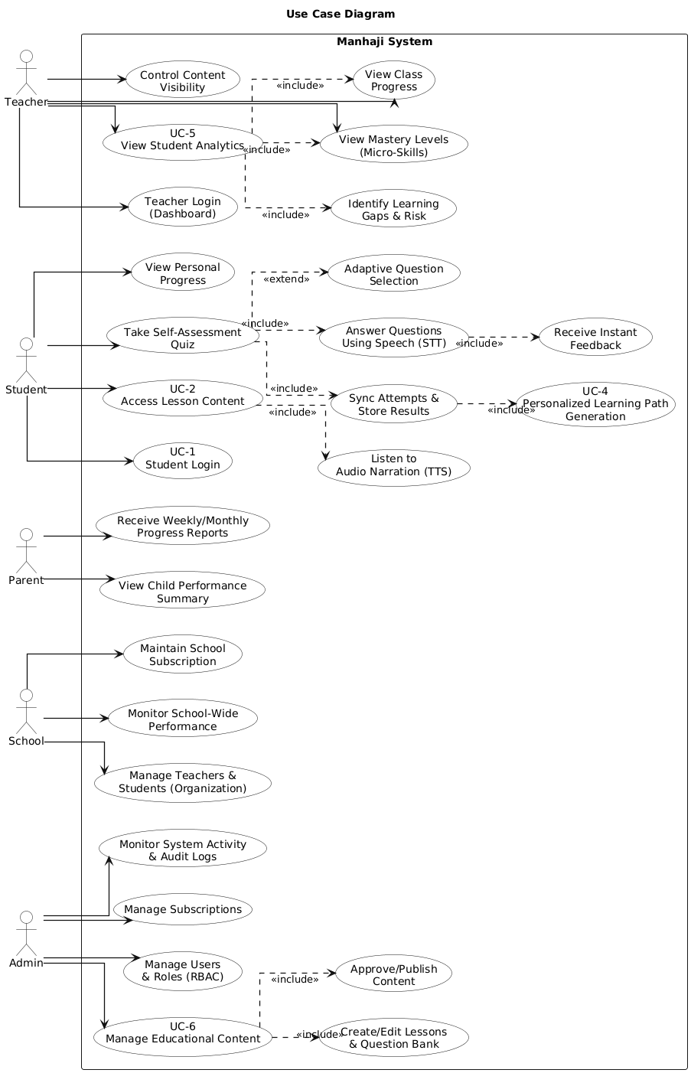
Figure 5:Use Cases Diagram

3.3 System Models

System models are used to provide a visual and logical representation of the internal structure and dynamic behavior of the Manhaji system. These models serve to bridge the functional requirements to make them concrete and explain how system components work, how data moves through them, and how users drive system behavior. This section outlines the system design prior to implementation.

The system models in Manhaji include Class Diagrams, Sequence Diagrams, Activity Diagrams, and State Chart Diagrams. Together, these models ensure the soundness, correctness, and coherence of the design.

3.3.1 Class Diagram

The class diagram shows the static structure of the Manhaji system by defining the properties of its main classes, their attributes, methods, and relationships. It provides a structural view of how data is organized.

Key classes in the system include: User, Student, Teacher, Parent, Admin, Lesson, Question, Quiz, Attempt, Progress, and Subscription.

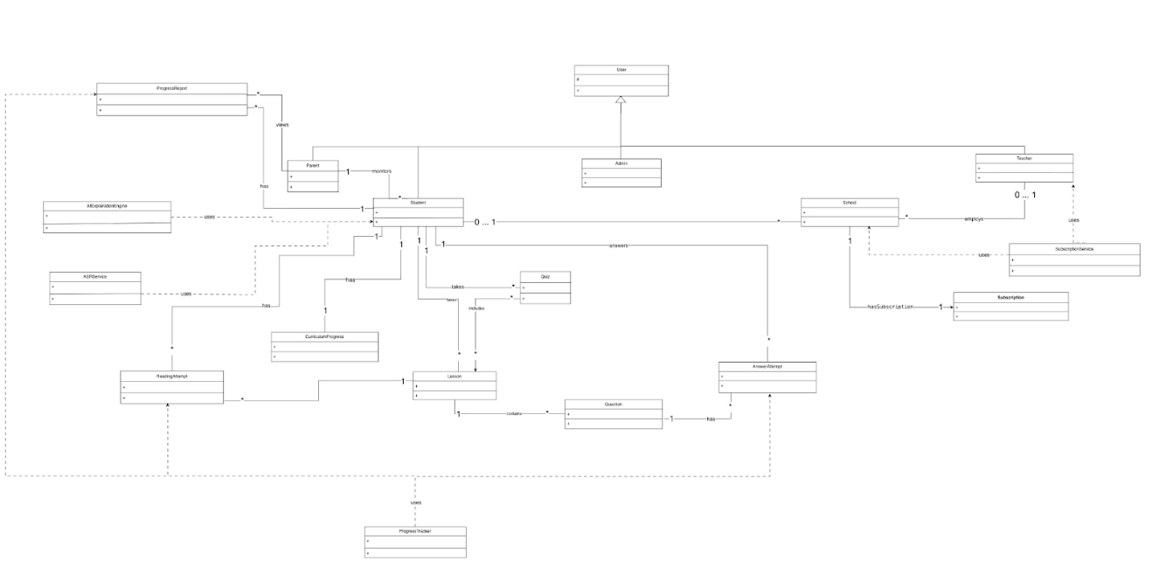
Figure 6: Conceptual class diagrams
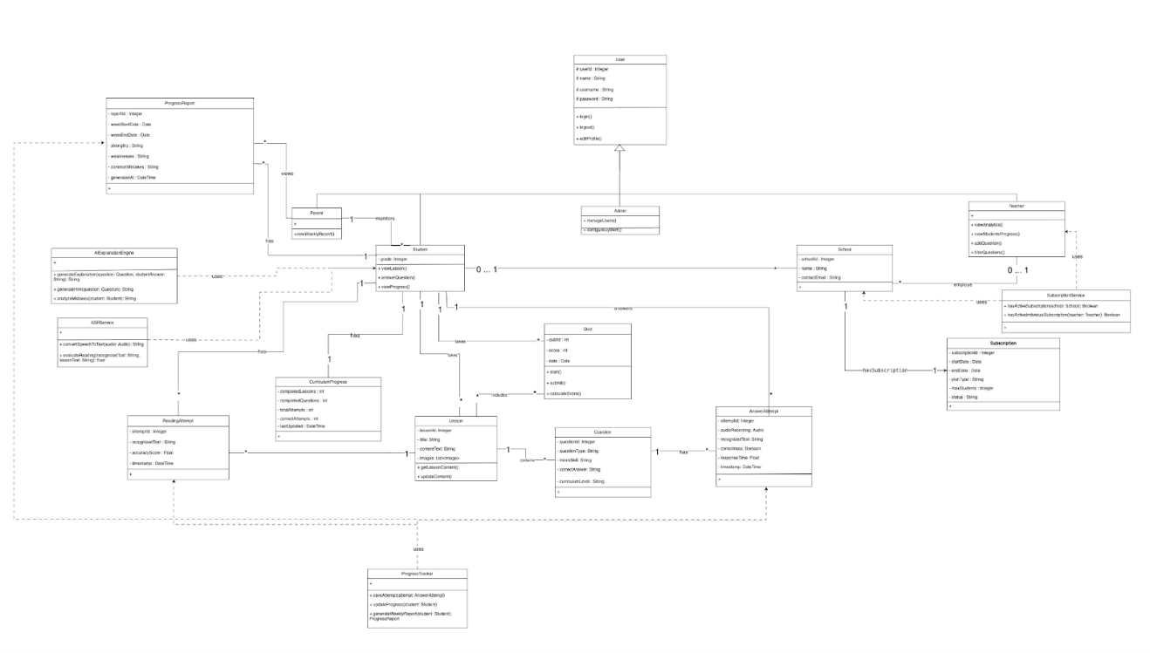
Figure 7: Class Diagram

Note: For more technical details Check the Appendices.

3.3.2 Sequence Diagram:

Sequence diagrams display interactions between system components in the order they occur to accomplish a particular use case. They care about the flow of messages between actors, user interfaces, system services and backend components.

UC-1: Student Accesses Lesson Content
This process is initiated when a learner logs in to the system and chooses a lesson. It is a network-based solution where the access is validated, then the lesson data is retrieved, and audio narration played and visual content displayed. The conversation is concluded when the completion of the lesson is registered.

UC-2: Student Generates Gamified Quiz
The student chooses from the lessons and asks for a quiz. The system formulates questions, records spoken answers, evaluates answers with AI (artificial intelligence), gives credit for correct answers, tracks progress and stores results.

UC-5: Teacher Views Student Analytics
The teacher logs into the dashboard, asks for analytics information about the students and gets back processed performance metrics, mastery indicators and trend visualizations that have been created by the analytics engine.

UC-1: Student Accesses Lesson Content

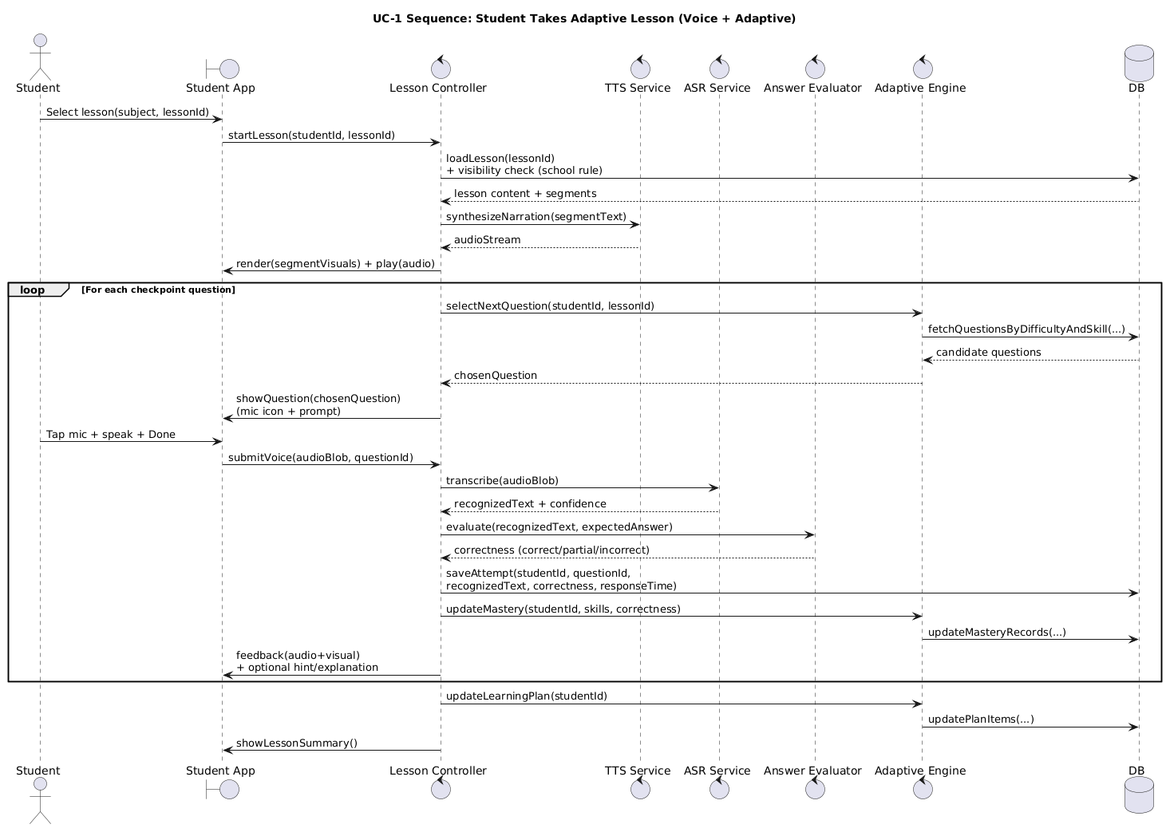
Figure 8: Sequence Diagram UC-1(Student Accesses Lesson Content)

UC-2: Student Generates Gamified Quiz

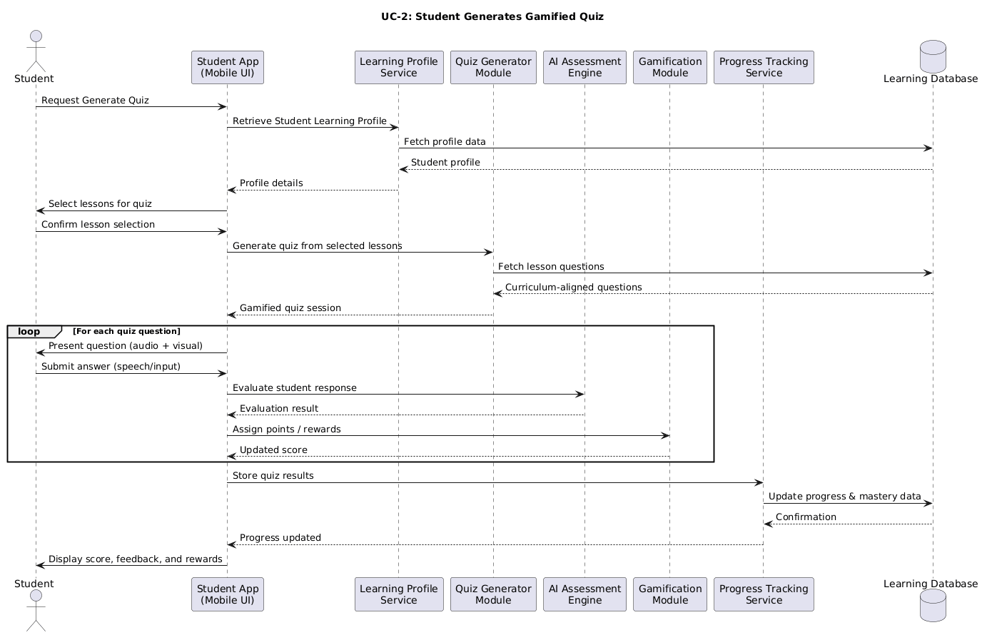
Figure 9: Sequence Diagram UC-2 (Student Generates Gamified Quiz)

UC-5: Teacher Views Student Analytics

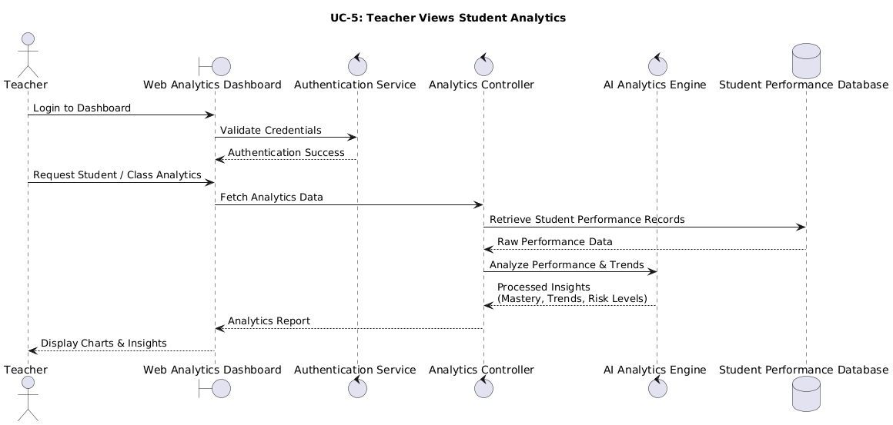
Figure 10: Sequence Diagram UC-5(Teacher Views Student Analytics)

3.3.3 Activity Diagram

Activity diagrams describe the flow of work among the primary functionalities in a system. They depict decision points, parallel actions, system reactions.

- UC-1 Activity Diagram
Illustrates a flow from lesson selection, content playback, student interaction and lesson completion logging.

- UC-2 Activity Diagram
Fig. 1 Depicts the generation of quiz, delivery of question, capturing speech input, evaluating feedback and score as well as progression update.

- UC-5 Activity Diagram
Explains how teachers retrieve analytics, filter data, review results, and leave the dashboard.

UC-1: Student Accesses Lesson Content

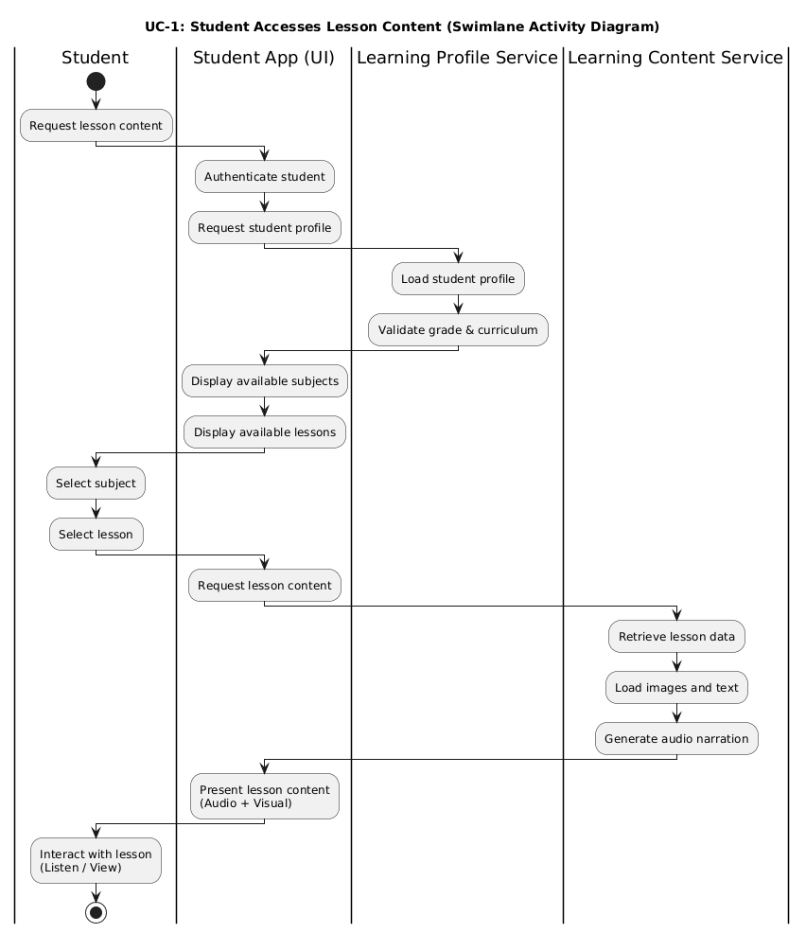
Figure 11: Activity Diagram UC-1 (Student Accesses Lesson Content)

UC-2: Student Generates Gamified Quiz

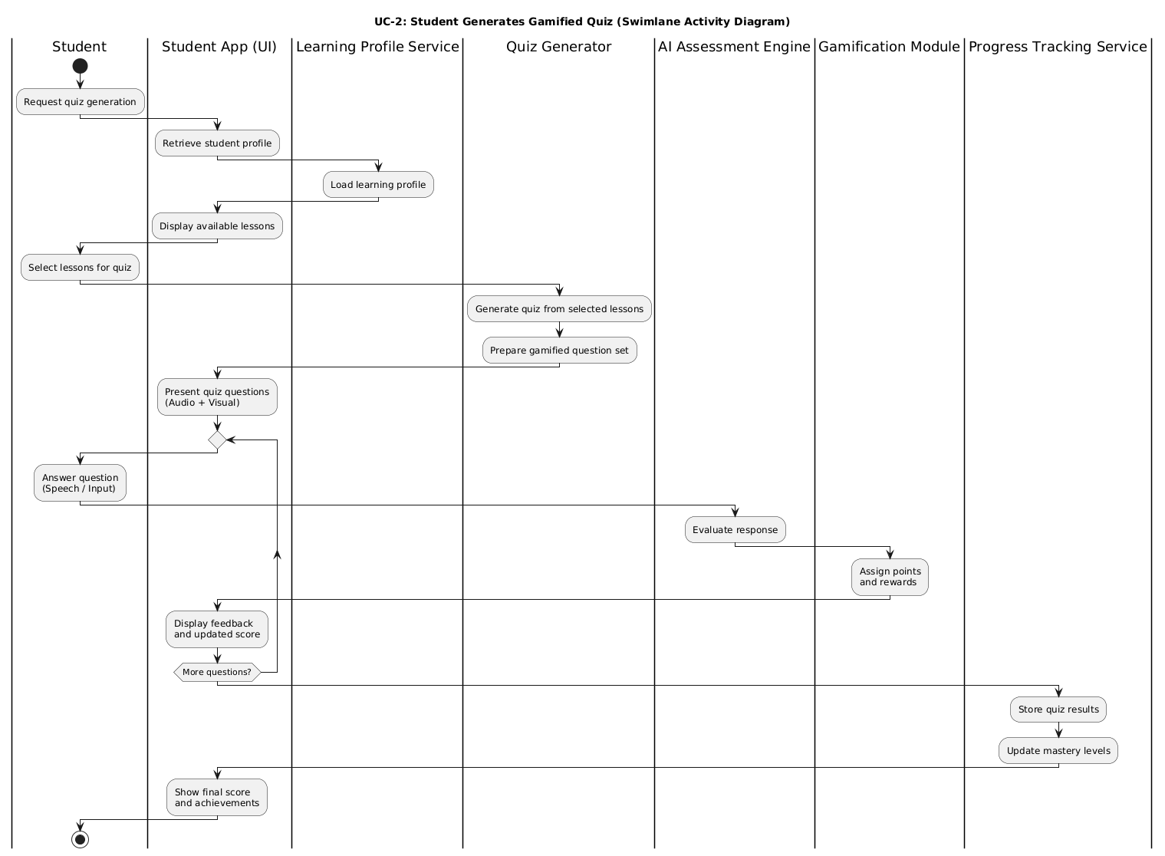
Figure 12: Activity Diagram UC-2(Student Generates Gamified Quiz)

UC-5: Teacher Views Student Analytics

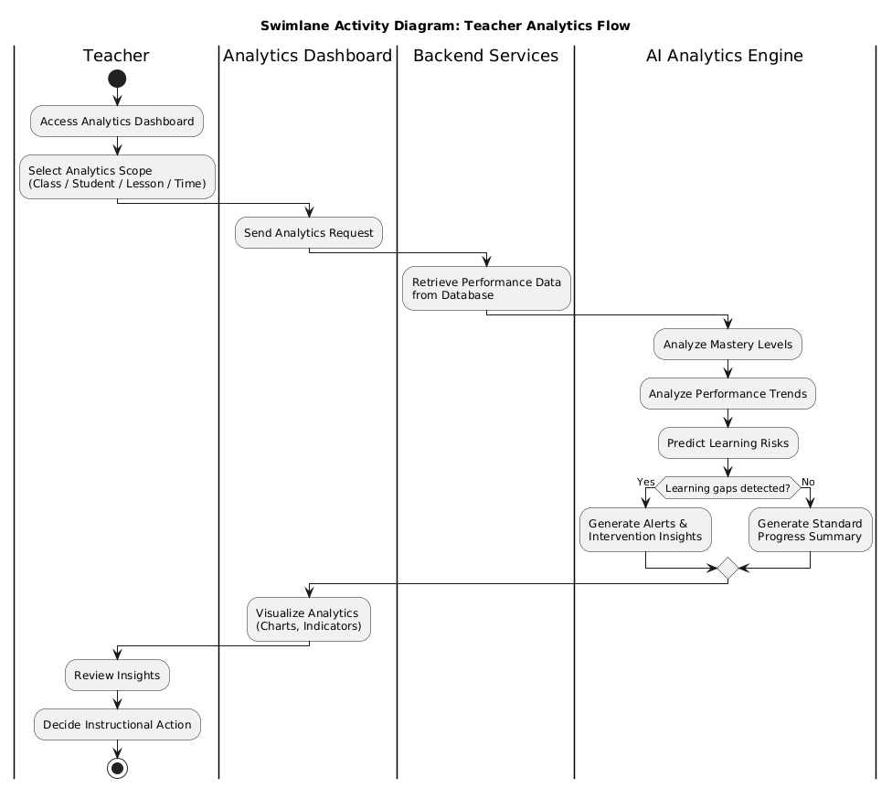
Figure 13: Activity Diagram UC-5(Teacher Views Student Analytics)

3.3.4 State Chart Diagram

State chart diagrams are used to show how system entities transition from one state to another as a result of logic design.

Lesson Session State Chart
A lesson session moves through stages like Idle, Lesson Loaded, Playing Content, Waiting for Response and Complete. Transitions between states are caused by student actions and system events.

Gamified Quiz State Chart
The system moves through various states: Quiz Generated, In Progress, Answer Evaluation, Feedback Granted and Quiz ended. The nation's 14 education systems guarantee that learning is drilled at the right pace and that teaching targets are reached.

A) Lesson Session State Chart:
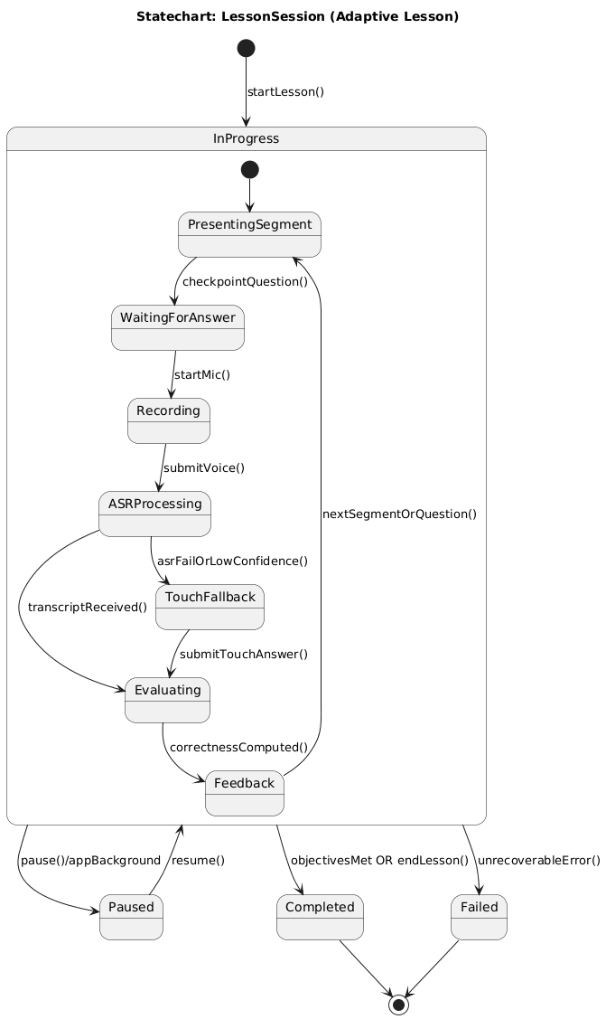
Figure 14: State Chart Lesson Session

B) Gamified Quiz State Chart:
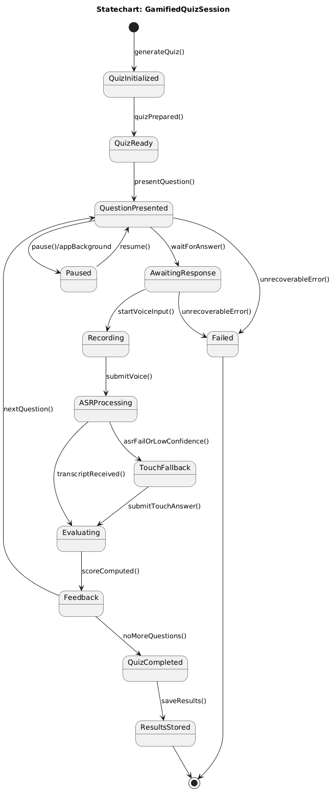
Figure 15: State Chart Gamified Quiz

3.4 System Architecture

Manhaji is built on a modular, service-oriented architecture to provide scalability, maintainability and maneuverability. The architecture divides responsibilities into clear decoupled sub-systems, similar to layers in an OSI model; where each layer has strictly dominant functional aspects and communicates with others behind controlled interfaces. This segregation provides the system with both the capability to evolve, and scale, and accommodate new AI features without disturbing existing common functionality.

At a high-level, the system is designed with a client–server architecture, where multiple clients (the student’s mobile app and the teacher’s web-dashboard) are linked to a centralised backend. BackEnd is responsible for data management, AI processing, logic learning and analysis; external voice service and AI services providing intelligent evaluation.

3.4.1 Sub-System
User Management Sub-System
This sub-system governs all user identities and access-control to the whole Manhaji system. It performs user registration, credentials validation, session maintenance and role checks applying to students, teachers, parents, schools and the admin.
Its barrier service protects access, verifies users will only interact with system features and data allowed by their role or subscription level. This sub-system is also responsible for user profiles and restores user states when login again.

Learning Content Sub-System
Curriculum-aligned learning resources are managed by the Learning Content subsystem. It saves lessons, units, textbook-based questions, images and audio narration.
This sub-system presents instructional content to students incorporating simultaneous audio narration and visual materials that enable instruction independent of a heavy reading requirement. Guarantees that we adhere to the Palestinian National Curriculum and helps with teaching in sequence over different periods.

Assessment and Quiz Sub-System
All testing functions (such as test generation, answer submission and evaluation) are performed by the sub-system. It creates quizzes that are created based on lesson and can obtain input from students mainly in spoken form.
The Assessment subsystem interacts with AI services for analyzing the answers spoken, calculating correctness scores and giving instant feedback. It also logs rich trial data to support adaptive learning and progress tracking.

Progress Tracking and Reporting Sub-System
There is also the Progress Tracking sub-system that records on a constant basis student interactions, quiz score results, lessons accomplished, and skill mastery levels. It collects fine-grained learning data to construct long-term performance profiles of each student.
Its features offer progress reports, mastery indicators and automated report cards for teachers and parents. This subsystem is highly responsible for early detection of learning gaps and data-driven educational intervention.

Teacher and Classroom Support Sub-System
Teachers are equipped with analytical devices and classroom-level insights through a web-based dashboard in this subsystem. It provides a way to see performance data for students and classes with both individual skill level tracking as well as skills usage in lessons.
The system also provides a learning data filtering and visualization mechanism that allows teachers to react on the fly to students' performances in order to influence the strategies of their classrooms.

Subscription Management Sub-System
Feature availability, depending on active subscription, is under the Subscription Management sub-system. It checks permissions of schools/teacher/individual users so that premium features like analytics or content beyond a certain point are only visible to those users.
This sub-system manages licensing business rules while being completely isolated from learning logic.

3.4.2 Software Architecture
The Manhaji architecture is based on levels of software: the presentation layer, application level, intelligent level, and data.

- Presentation Layer:
Consists of a student mobile application (Flutter-based) and teacher/admin web interface. This is the layer for user interaction, content viewing, audio playback, and voice input.

- Application Layer:
This layer is based on a Spring Boot backend, and it provides a set of RESTful APIs that receive the user request messages, orchestrate learning workflows, apply business rules, and coordinate communication among sub-systems.

- Intelligence Layer:
This layer includes speech-to-text AI service, answer difficulty adjustment, and personalized learning path generation AI services. It processes raw data of interactions into learning insight.

- Data Layer:
Utilizes a relational database to save users, lessons, quizzes, attempts, progress statistics, and subscription details. This layer provides consistency, integrity, and persistence to the data spanned across sessions and devices.

This layered design enables loose coupling and makes the system maintainable and extendible, which is capable of adopting AI model integration in future.

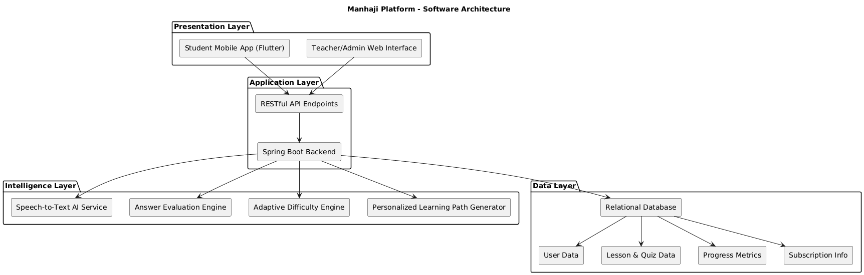
Figure 16: Software Architecture Diagram

3.4.3 Deployment Diagram

Manhaji's deployment architecture is cloud-based and distributed to enable availability and scalability across different nodes.
Devices from students (tailored to work in both Android and iOS) execute the mobile application, sending and receiving data to/from the backend through secured internet connections.

Teachers and administrators use their web browser to log into the system and are looking at the same backend services.

The main system logic is deployed on the backend application server and the API it exposes.

Speech recognition, text-to-speech, and intelligent answer analysis are offloaded to external AI services.

All persistent system data is placed in a centralized database server.

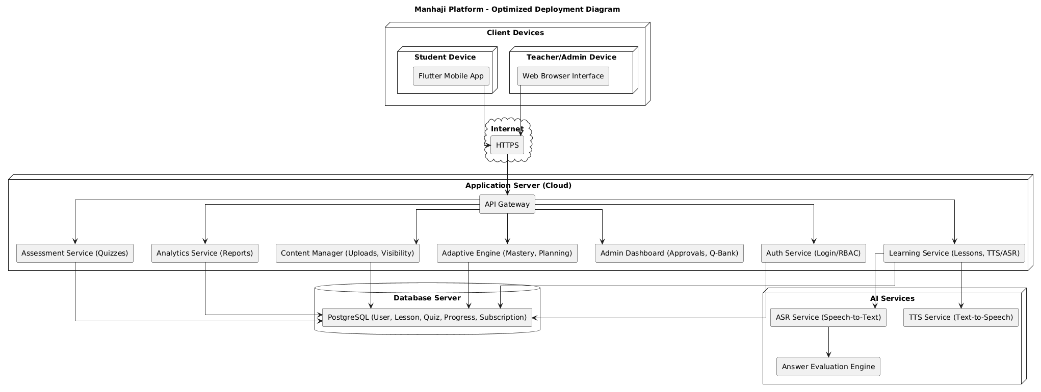
Figure 17: Deployment Diagram

3.5 Data Management and ERD

The database is responsible for storing structured educational data, user profiles, test outcomes, progress records and subscription information. We chose a relational model because it is more performant than NoSQL, supports complex relationships between entities and has strong data consistency guarantees in our use case as the model integrates nicely with Spring Boot for backend.

All Data transfers occur via secure backend services, regulated access, role-based visibility restrictions and comply with privacy regulations related to children’s data.

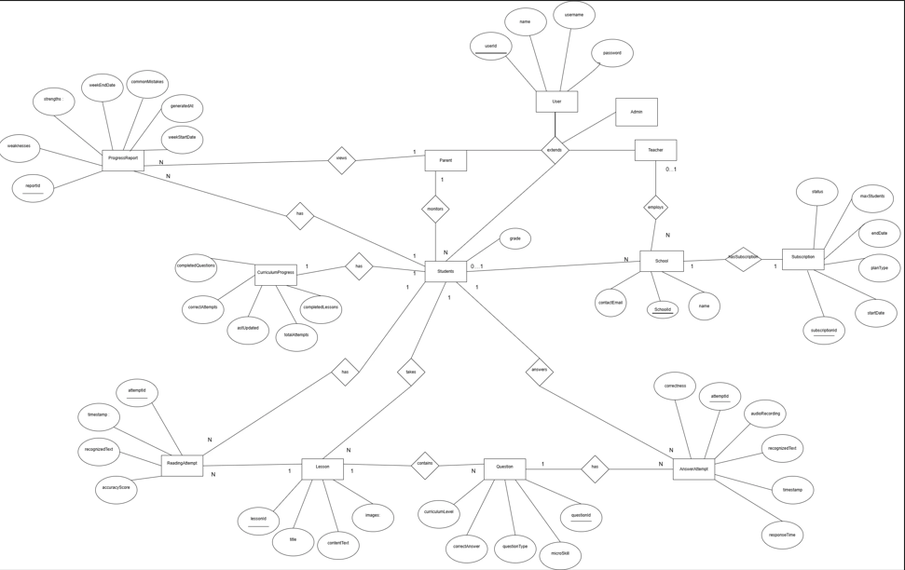
Figure 18: ERD

Chapter 4: Conclusion and Future works

Conclusion

This paper described the development and validation of Manhaji, an AI-enabled personalised learning environment and performance analytics platform for early-grade students. By providing adaptive learning, voice-based interaction, and continuous performance analysis in a curriculum-oriented environment it seeks to overcome the limitations of current as well as traditional digital learning.

Manhaji allows students to learn by hearing and speaking while minimizing dependence on reading and writing in the early learning phases. The AI driven solution measures student performance, automatically scales question difficulty and provides an individual learning path by students' mastery level and knowledge gaps.

The system also has advanced analytics for teachers and continuous diagnostics in order to support early identification of learning issues by the teachers. Making progress visible to parents promotes transparency and complements learning at home.

Technically, the system architecture is modular and scalable for both school-based learning and independent study. The proposed technologies allow to get a cross-platform solution, secure processing of the data and design supporting system growth.

In summary, Manhaji illustrates how AI can be used to educate young children more effectively by increasing personalization and engagement; pathways for learning outcomes – at training system is in concert with the local curriculum.

Future Works
Future development of the Manhaji system will feature automaticity as well as content management and organization.

Automated Quiz and Review Generation
As a result, the system will create practice quizzes and review activities by AI. Quizzes will be made on certain lessons or units and modified for individual student mastery and weakness. This way you can practice where you need to for an efficient revision without creating manual quiz questions.

Lesson Content Upload
Teachers can upload lessons’ original content files in many document formats such as PDF, DOCX, PPTX including images and audio files. A list of uploaded lessons will be marked with metadata including grade, subject, unit and lesson titles for organization and alignment to curriculum.

Question Bank Management
Teachers will be able to ask for question banks for an individual lesson, generated by AI. The available question types will be multiple-choice, true/false and short-answer questions. There will also be a difficulty level associated with each question to facilitate adaptive testing and individualized instruction.

Content Request Status Control
Teaching materials uploaded will be saved as requests within the system. Each request will be in one of three states: PENDING, APPROVED, or REJECTED. This action will ensure content validation and academic quality assurance processes prior to student access.

4.1 Review of the project

In this study, we developed and evaluated Manhaji to enhance early-grade learning using artificial intelligence. The gig was set up to offer adaptive, voice-based and curriculum-linked learning with performance analyzation.

The initiative outlined a full system architecture that covers lesson presentation, spoken interaction, AI-enhanced evaluation and feedback, adaptive questioning and personalized learning path creation. Every piece was meant to facilitate personalized learning and ongoing assessment.

Learners use the system by listening to spoken lessons and giving spoken answers. The system assesses responses through AI, dynamically levels difficulty and monitors mastery at the micro-skill level.

The project also built analytics tools for teachers and reporting features for parents. Teachers can track the progress of their students and see where learning gaps are so that they may provide timely intervention. Parents receive structured progress summaries.

Hence, on the whole, the project achieved its goals in these two design areas by offering a scalable and sustainable system design that incorporates artificial intelligence for early-grade learning as it fits the local curriculum.

4.2 Next Semester Plan

Implementation Stage | Start Date | End Date
Backend Setup & Database Creation:  Set up server, database structure, and API skeleton | 20 Feb | 01 Mar
Multimedia Lesson Module Development:  Implement text-to-speech narration and image integration | 02 Mar | 15 Mar
Speech Answer Capture & Evaluation System: • Build speech-to-text pipeline and answer correctness logic | 16 Mar | 30 Mar
Adaptive Questioning Engine: Implement difficulty adjustment, micro-skill tracking, and auto-question selection | 31 Mar | 15 Apr
Personalized Learning Plan Generator: Develop learning profile model and recommendations engine | 16 Apr | 30 Apr
Automatic Quiz Generator: Create question generation module from lessons/units | 01 May | 10 May
Student App UI Development: Implement screens for lessons, speech answers, and adaptive questions | 11 May | 25 May
Teacher Dashboard & Analytics Module: Build progress reports, weak-skill charts, and class overview | 26 May | 10 Jun
Integration & System Testing: Test all modules together (app + backend + AI) | 11 Jun | 25 Jun
Final Debugging & Optimization: Fix issues, optimize performance, and complete documentation | 26 Jun | 30 Jun
Project Implementation Completed | 01 July | 01 July

Bibliography

[1] Flutter, “Flutter - Build apps for any screen,” [Online]. Available: https://flutter.dev.
[Accessed: 21 Jan. 2026].

[2] W3Schools, “HTML / CSS / JavaScript Tutorial,” [Online]. Available: https://www.w3schools.com.
[Accessed: 21 Jan. 2026].

[3] Spring, “Spring Boot,” [Online]. Available:
https://spring.io/projects/spring-boot/.
[Accessed: 21 Jan. 2026].

[4] MySQL, “MySQL - Open Source Database,” [Online]. Available: https://www.mysql.com.
[Accessed: 21 Jan. 2026].

[5] PyPI, “SpeechRecognition,” [Online]. Available: https://pypi.org/project/SpeechRecognition/.
[Accessed: 21 Jan. 2026].

[6] Speechify, “Text-to-Speech Software,” [Online].
Available: https://speechify.com.
[Accessed: 21 Jan. 2026].

[7] University of San Diego, “Artificial Intelligence in Education,” [Online]. Available: https://onlinedegrees.sandiego.edu/artificial-intelligence-education/. [Accessed: 21 Jan. 2026].

[8] Pan, Z., Biegley, L., Taylor, A., & Zheng, H. (2023). A Systematic Review of Learning Analytics-Incorporated Instructional Interventions on Learning Management Systems. The Journal of Learning Analytics.
Available : (ResearchGate)

[9] Martínez-Martínez, A., Gómez-Cambronero, Á., Montoliu, R., & Remolar, I. (2025). Towards the Adoption of Recommender Systems in Online Education: A Framework and Implementation. Big Data and Cognitive Computing, 9(10), 259. Available :(MDPI)

[10] Bhatt, S. M. (2025). Teacher-centric educational recommender systems in K12: insights and applications. [Article].
Available: (ScienceDirect)

[11] T. M. A. Zayet and M. Ismail, “What is Needed to Build a Personalized Recommender System: A Systematic Review of E-learning in K12 (2017–2021),” PubMed Central, 2022. [Online].
Available: (PMC).

[12] Review: A systematic review of the role of learning analytics in supporting personalised learning. (2024). MDPI, Education Sciences.
Available: (MDPI).

[13] CEUR-WS, “A Systematic Narrative Review of Learning Analytics Research in K-12,” CEUR Workshop Proceedings, 2022. [Online].
Available: (CEUR-WS)

[14] Review: A Review of Learning Analytics Opportunities and Challenges for K-12. (2023-2024). PMC. (PMC)

[15] Y. Tabasi, I. B. Tondowala, M. S. Tupamahu, F. P. Soa’e Sigilipu, and K. A. K. Septiana, “The effectiveness of technology-enhanced learning tools in English language education,” Journal on Education, vol. 6, no. 4, pp. 21589–21601, Jun. 2024.

[16] I. Abu-Ayyash, “Education in Palestine: Subsequent crises and accumulated learning loss,” Journal of Social Sciences, Democratic Arabic Center for Strategic, Political & Economic Studies, vol. 8, no. 33, pp. 51–75, Sep. 2024.

[17] Z. Yu, L. Yu, Q. Xu, W. Xu, and P. Wu, “Effects of mobile learning technologies and social media tools on student engagement and learning outcomes of English learning,” Technology, Pedagogy and Education, pp. 1–19, 2022, doi: 10.1080/1475939X.2022.2045215.

[18 ]H. Ramahi, “Education in Palestine: Current Challenges and Emancipatory Alternatives,” Rosa Luxemburg Stiftung – Regional Office Palestine, Nov. 2015.

Appendices

Implementation-level UML Class Diagram
(more technical details):

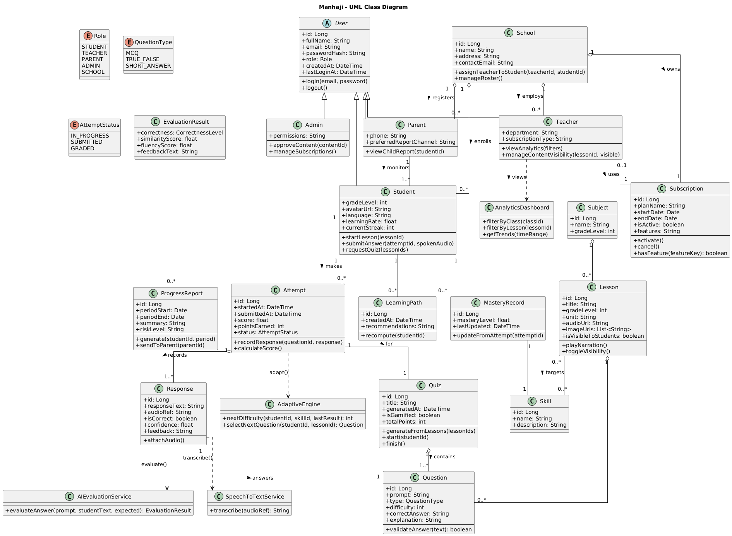
Figure 19: Implementation-level UML Class Diagram

Use Case Specifications:

Use Case 1: Student Accesses Lesson Content (UC-1):

Primary Actor: Student

Preconditions
- The student has an account in the system.
- The pupil is now signed into the app.
- The student is offered grade level and curriculum.
- Selected lesson has been approved and published by an Admin.
- Internet connection for voice narration services.

Brief Description
This use-case describes how a student reads and uses lessons in the Manhaji project. The lesson is presented in a multimodal way (combination of audio narration, visual illustrations/photographs and minimal text), allowing early-grade kids to learn at their own pace no matter what their reading or writing ability maybe. The system also guarantees that lessons are content-aligned, age-appropriate and adapt to the behavior of student's interaction.

Postconditions
Success Postconditions
- Lesson completion is recorded.
- User progress is stored in the database.
- The learning status of the student is maintained up to date.
Minimal Guarantee
- student data is lost in case session is interrupted.

Trigger
The student consciously chooses a lesson from the list of all available lessons on his/her dashboard.

Main Success Scenario (Primary Flow)

- The student starts the Manhaji app on his or her supported device.
- The system authenticates the student and obtains a learning profile of the student, including a grade level, an assigned curriculum for the student, and prior progress thereof.
- The student dashboard appears on the screen, which indicates the subjects and lessons that are available to choose for your year level.
- The student chooses a topic through the dashboard.
- The list of lessons related to the chosen subject is loaded and displayed by the system.

- The student chooses to explore a certain lesson.
- The system checks the availability of a lesson and obtains the information (text, image and audio) for the selected lesson from database, based on which: Lesson text, visual images associated with text, Audio - data files for narration
- The teaching interface is started, and the view learning content is shown on the screen.
- The text-to-speech service in the system will also read out the text for you.
- The student listens to the audio lesson and observes the visual materials.
- Lesson segments are easy to navigate (next, previous, replay) for the student.
- Audio narration is queued to the currently viewed lesson segment by the system.
- The system is always capturing detailed student interaction data such as: Time spent in each lesson part, Navigation actions, Lesson progress.
- The lesson moves onto its final section for the student.
- There are no remaining lesson segments that need to be visited because the system verifies if all lessons were visited.
- The lesson is logged as ‘Finished’ in the learning students profile.
- The database entries for the student’s progress and mastery are updated in the system.
- The student is guided through available next steps, including: Proceeding to practice activities, Generating a quiz, Exiting the lesson.

Alternative Flow A1: Student Exits Lesson Early
Condition:
A student tries to leave or exit out of the lesson/app before it's done.
Flow:
- The student exits the lesson screen intentionally or unintentionally.
- It is detected by the system that the lesson has not been accomplished.
- It saves where you last left off so no more wondering what episode you were up to.
- The student’s profile status is labelled “In Progress”.
- This saved state is recorded in the database.
- When the student next logs in, they are prompted to continue with their lesson.
- Lesson begins exactly where a student stops.

Postcondition:
No history forgotten, so that the learner can seamlessly learn again later.

Alternate Flow A2: No Audio Description
Condition:
the lesson audio is not played with TTS.
Flow:
- Sounds narration plays and tries to play the audio. A fault happens, or the audio service is not available. The app works to automatically reinstate the audio.
- If unsuccessful:
• The student receives a visual warning.
• All images remain available to students with vision.
- The lesson carries on in stealth mode.
The voice problem is recorded for a service request tracker.
Postcondition:
The student continues learning using visual materials without system interruption.

Alternate Flow A3: Loss of Internet Connection During The Lesson
Condition:
The student loses their internet connection in the middle of class.
Flow:
- The disconnection of the network is detected by the system.
- Audio playback halts automatically.
- A no connection error message is displayed on the screen.
- The current lesson state is stored away.
- The system continuously attempts to reconnect.

Postcondition:
It's not enough to disrupt the lesson for a moment of lost connectivity.

Use Case 2: Student Creates a Gamified Quiz

Primary Actor
Student (Grade 1–4 learner)

Brief Description
This feature allows young learners to transform past lessons into an entertaining, voice-based quiz game. The app makes questions from the material they have already studied. The student answers verbally, the system listens and verifies how correct it is, awards them points, presents rewards and shows them what progress they are making in their studies.
Preconditions
- The learner is registered in the system.
- They’ve already done or accessed at least one lesson
- It has ready quiz material for that lesson.
- Speech recognition is working.

Trigger
The student clicks the "Start Quiz" button for a lesson.
Postconditions
If successful:
• The quiz result is stored by the system.
• A new level of mastery for the student is updated.
• The student is also rewarded to add points to the student’s profile gamification.

At minimum:
- No progress is lost, even if the quiz is interrupted.

Main Success Scenario (Primary Flow) – UC-2
- The student opens the Manhaji app.
- The app signs them in, and their learning profile is loaded.
- The system displays a list of lessons they’ve already visited.
- The student selects the lesson they’d like to be quizzed on.
- They choose the option to generate a gamified quiz.
- The system checks that a quiz can be created for that lesson.
- It grabs the key lesson points, goals, and questions.
- the app builds a custom quiz including:
  - A set number of questions
  - An initial difficulty level

- The quiz game starts! It shows: A live score counter, Fun reward icons, A progress bar
- The first question is shown on the screen.
- The system reads the question out loud.
- It turns on voice input mode.
- The student answers by speaking.
- The system records the answer.
- The speech-to-text tool converts the answer into written form.
- AI evaluates the answer for: Accuracy, Partial understanding, Clarity.
- The system marks the answer as correct, partly correct, or incorrect.
- Instant feedback is given through sounds and visuals (like animations or icons).
- Points are awarded based on how accurate and clear the answer was.
- The quiz score is updated.
- The system adjusts the difficulty for the next question.
- The next question is shown.
- Steps 10–22 are repeated until the quiz is complete.
- The system ends the quiz.
- A final score and performance summary are generated.
- The system updates the student’s mastery level, lesson progress, and awards.
- The quiz results are saved.
- A summary screen appears showing: The score, Positive feedback, Suggestions for what to do next

Alternative Flow A1: Speech Recognition Failure
Condition:
The system fails to correctly capture or transcribe the student’s spoken answer.
Flow:
- The student submits a spoken response.
- The system attempts to capture the audio input.
- The speech-to-text service fails or returns an invalid transcription.
- The system prompts the student to repeat the answer.
- The student repeats the spoken response.
- The system reattempts speech recognition.
- If recognition succeeds, the system continues with answer evaluation.
- If recognition fails again, the system activates a fallback input method.
- The quiz proceeds without terminating the session.

Postcondition:
The quiz continues without loss of progress.

Alternative Flow A2: Incorrect Answer Submitted
Condition:
The student provides an incorrect answer.
Flow:
- The system evaluates the spoken response.
- The system determines the answer is incorrect.
- The system provides corrective feedback.
- The system logs the error for skill-gap tracking.
- The adaptive engine lowers the difficulty of the next question.
- The system selects an easier or supportive follow-up question.
- The quiz continues.
Postcondition:
Teaching gaps are captured and acted upon through adaptive instruction.

Alternative Flow A3: Repeated Incorrect Answers
Condition:
The student answers multiple consecutive questions incorrectly.
Flow:

- The system detects repeated incorrect responses.
- The system triggers adaptive remediation logic.
- The system provides additional hints or simplified explanations.
- The system selects lower-difficulty questions.
- The system reduces penalty impact on score.
- The quiz continues with adjusted difficulty.

Postcondition:
The student stays motivated and is not discouraged.

Teacher Views Student Analytics (UC-5)

Primary Actor
Teacher

Brief Description
A use case for a teacher reviewing student's learning analytics is: The teacher wants to view the students' learning analytics in an online dashboard description. It also offers on-the-fly performance data, second-chance indicators of mastery, progress insights and AI-created insights to inform instructional and early actions.

Preconditions
- The teacher does have an account.
- The teacher is authenticated.
- Assigned students are accessible to the instructor.
- There is some data available on student outcomes.

Trigger
Once logged in, the teacher clicks on the Analytics Dashboard option.

Postconditions

Success Postconditions
- Teacher adequately uses student performance data to review achievement.
- No data is modified.

Minimal Guarantee
- Analytical data is saved, even if the session is suddenly interrupted.

Main Success Scenario (Primary Flow) – UC-5\

- The teacher logs in to the Manhaji web platform.
- The teacher is asked for the username and the password.
- Teacher logs in using the below valid credentials.
- The system authenticates the teacher.
- The system checks the position and permissions of teachers.
- The teacher dashboard is displayed by the system.
- The teacher clicks on the Option Student Analytics.
- The analytics report system gets the analytics data for who is assigned to the teacher.
- The system compiles student performance information.
- The system analyzes metrics; one or more of the following indicators: Lesson completion status, Quiz scores, Skill mastery level, Performance trends
- This system introduces the summary analytics view.
- The lecturer chooses a particular class or student.
- The system collects the detailed analytics for the selected scope.
- The system shows granular performance information such as: Student by student performance, Patterns of errors, Mastery gains over time.
- The system flags students who are at risk of falling behind.
- The teacher then applies optional filters (lesson, date range, skill).
- The view of analytics is updated has been filters being applied.
- The teacher reviews analytics insights.
- The teacher is returned to the analytics dashboard.

Alternative Flow A1: Analytics Data Load Slowness
Condition:
Processing of analytics is slower than needed.
Flow:
- The teacher requests student analytics.
- The system then starts aggregating and processing the data.
- The latency for processing the data is too long.
- The system is showing a loading sign.
- The background processing is still running.
- Analytics is shown once the processing is done.
Postcondition:
Analysis is presented without loss or corruption of data.

Glossary (or data dictionary):

ALS | Adaptive learning systems
DBMS | Database management system
AIED | AI in Education
TTS | text-to-speech

Prototypes:

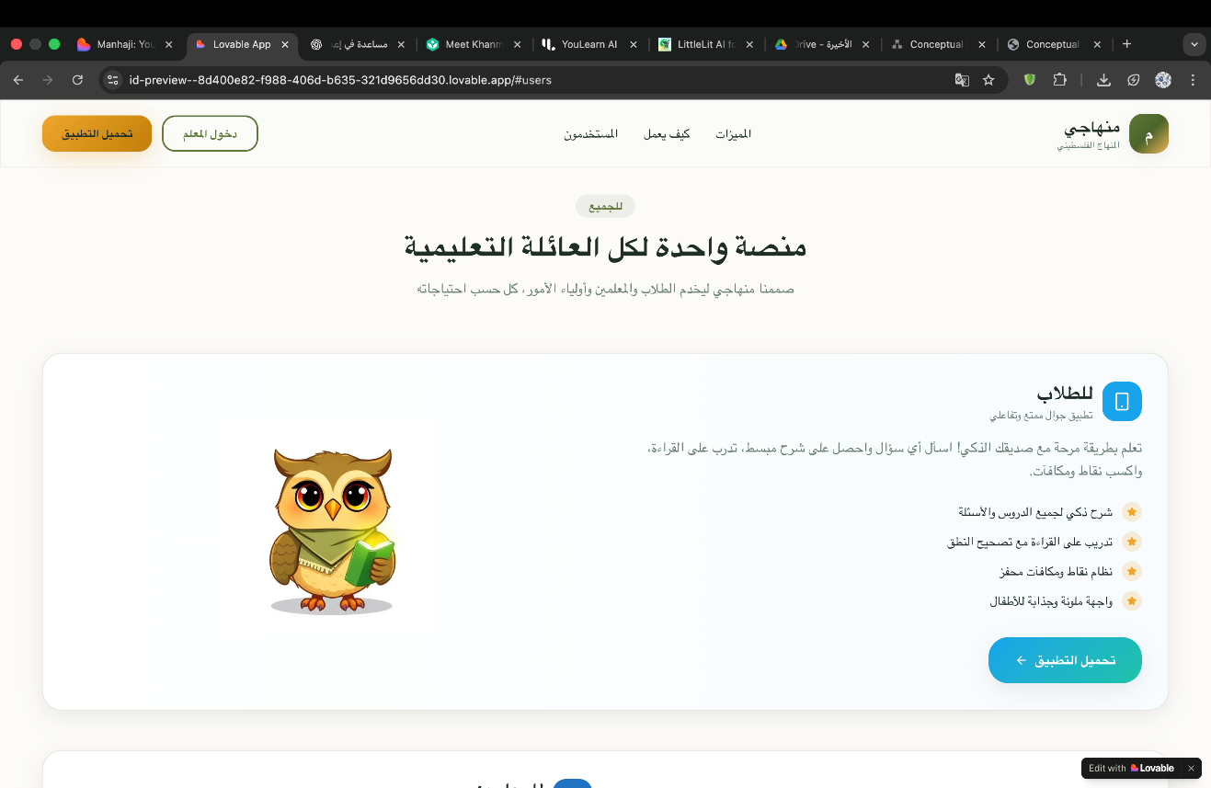
Figure 20: prototype1
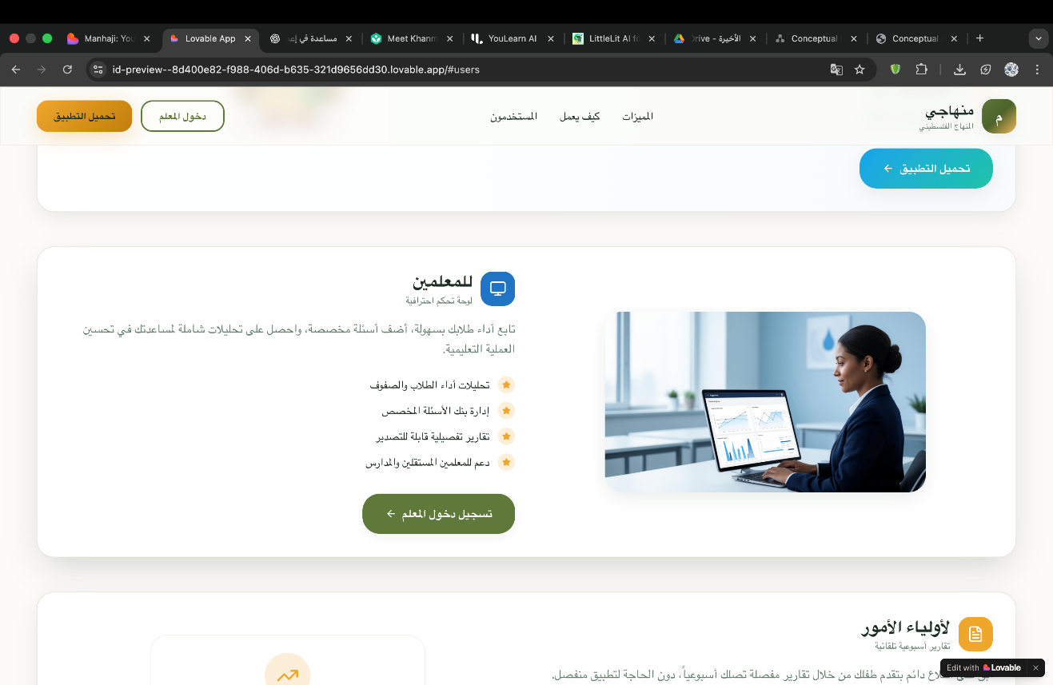
Figure 21: prototype2

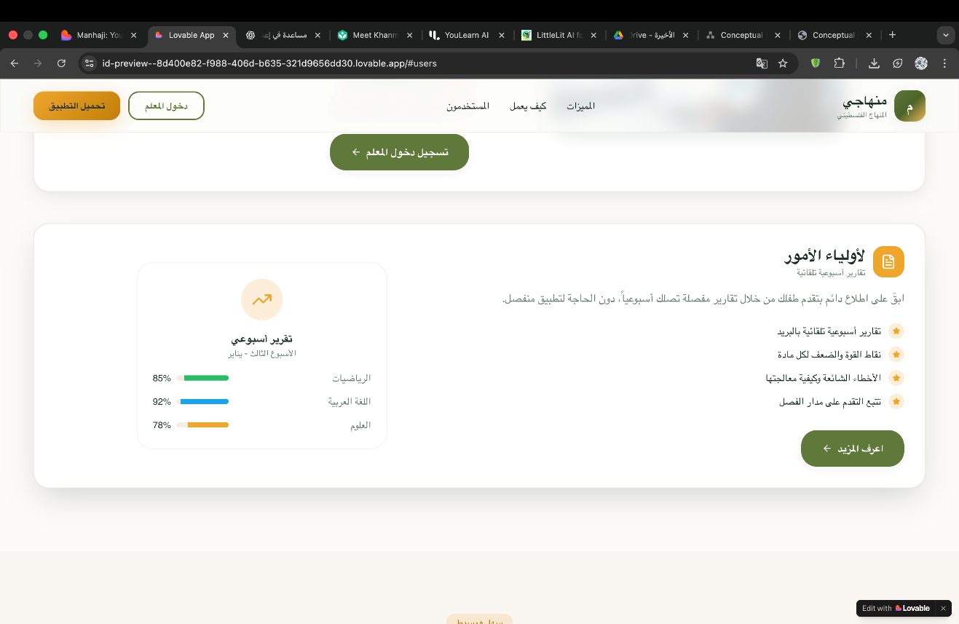
Figure 22: prototype3

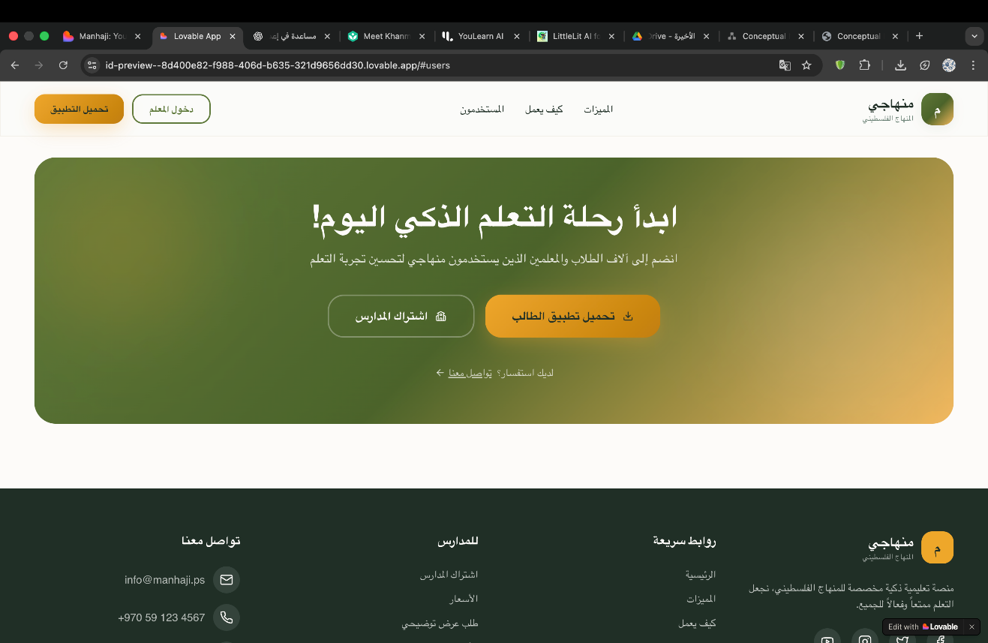

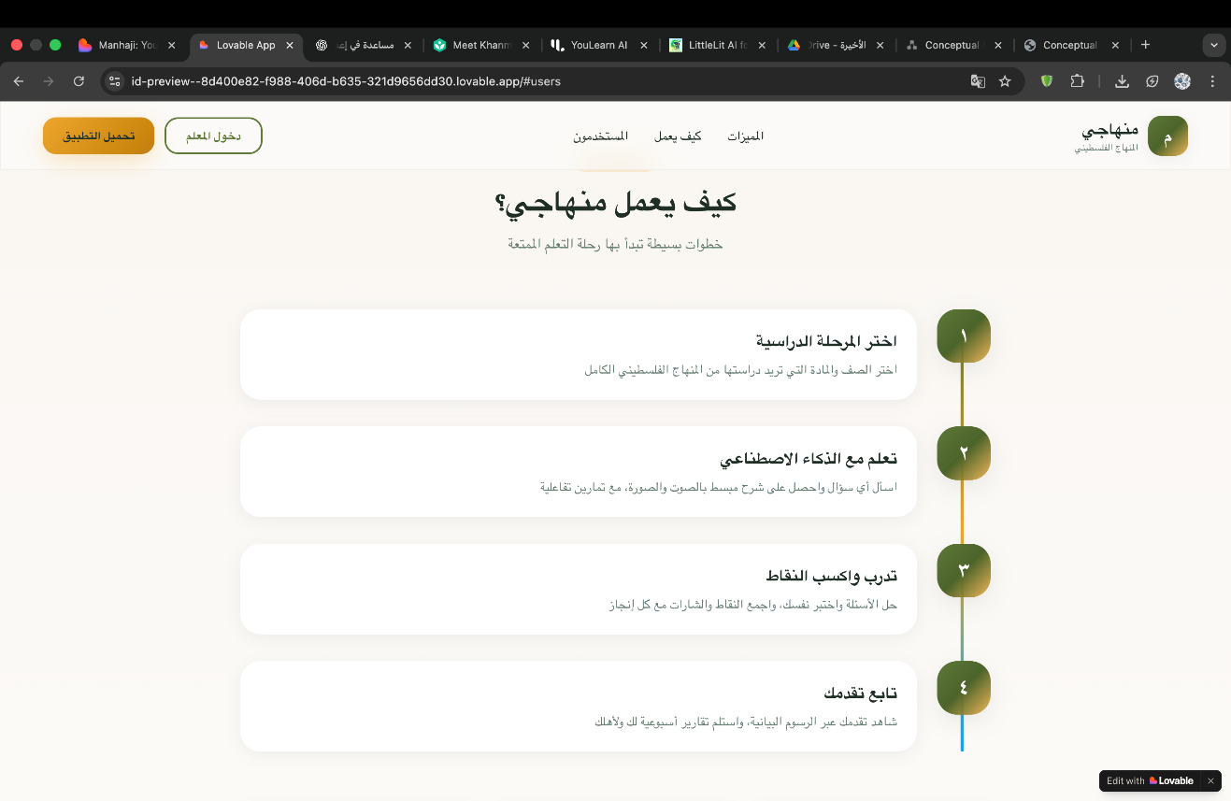

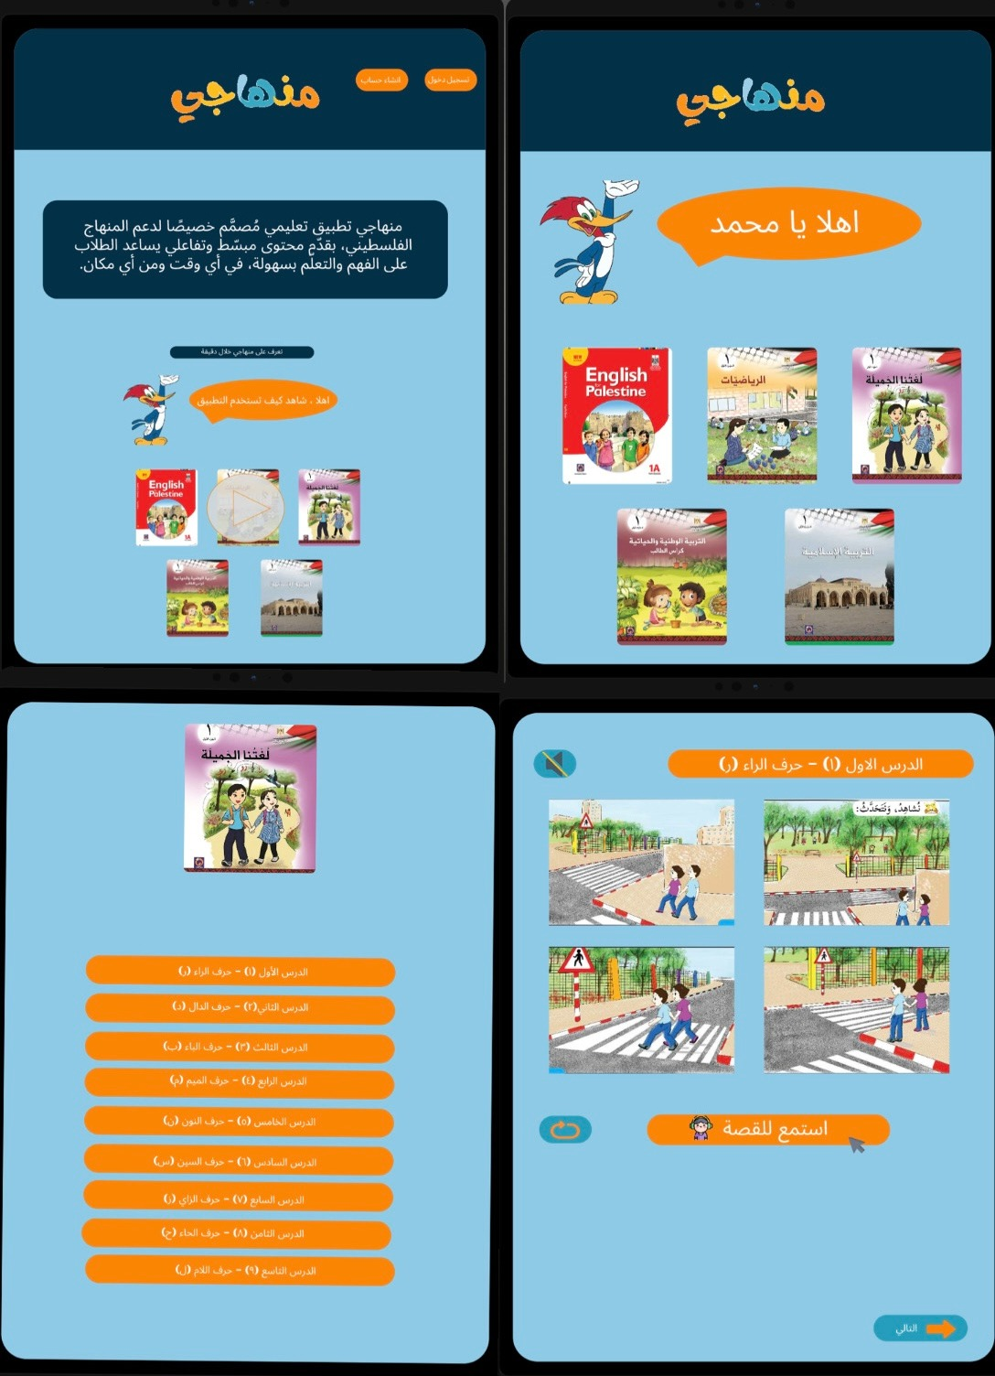
Figure 23: prototype mobile
